IN CASE YOU MISSED IT (ICYMI):

LA CITY COUNCIL PRESIDENT KERKORIAN CO-HOSTS

CONTRACTING OPPORTUNITITES WORKSHOP WITH MWIS

On August 29, 2024, Los Angeles City Council President Paul Krekorian co-hosted with Merriwether & Williams Insurance Services (MWIS) a webinar entitled, “Navigating City and Metro Contracting Opportunities.” The webinar aimed to provide small, local, and diverse contractors with the tools and information needed to successfully compete for public contracts. The event was a component of the LA Regional Contractor Development and Bonding Program (CDABP), which MWIS, a Hub International Company, administers on behalf of the City of Los Angeles, LA Metro, and the County of Los Angeles.

Councilman Krekorian began the webinar by warmly welcoming attendees and assuring them of his strong advocacy for local businesses in the City Council. As the son of a micro business owner and a former private sector attorney representing businesses for 20 years, Councilman Krekorian assured contractors of his commitment to making LA a better place for local businesses. He said, “I am here as the Council President, but I'm also here as a Metro Board Member, and in both capacities, I am eager to give your businesses greater opportunity to do business with our agencies.”



"I am here as the Council President, but I'm also here as a Metro Board

Member, and in both capacities, I am eager to give your businesses

greater opportunity to do business with our agencies."

LA City Council President Paul Krekorian

Lakeisha Bearden, Director of Program Development at MWIS, gave a presentation on CDABP’s core services, which includes assisting contractors in overcoming barriers to bonding. Ms. Bearden said the program has helped many contractors successfully bid on projects with the City of Los Angeles and grow their businesses. Referring to the upcoming projects for the 2028 Olympics in LA, Ms. Bearden said, "The opportunities are there, and we can all share in the upcoming wealth."

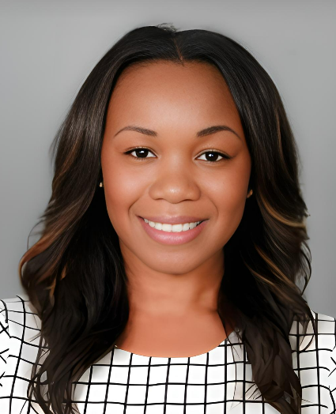

*"The opportunities are there, and we can all share in the upcoming wealth."*

*Lakeisha Bearden, Director of Program Development, MWIS*

Juan Garcia, CEO of PG Cutting Services, shared his experience as a contractor who benefited from the program. He explained how the program helped his business development and provided a real-life example of CDABP’s effectiveness. He emphasized the value of the CDABP in providing opportunities for small businesses to participate in procurement and grow their business. He cited the program's assistance in helping him obtain his first performance bond, which led to him securing higher-profile projects. “We had a need, and the program helped us get our first performance bond. Through that, we’ve been able to get on higher-profile projects,” said Mr. Garcia.

“We had a need, and the program helped us get our first performance

bond. Through that, we’ve been able to get on higher-profile projects.”

Juan Garcia, CEO of PG Cutting Services

In addition, representatives from the CDABP's sponsor agencies, including Los Angeles World Airports (LAWA), LA Metro, the LA Department of Public Works' Bureau of Contract Administration (BCA), and the LA Department of Water and Power (LADWP), took part in the webinar. They talked about the projects available within their departments to promote the involvement of small and diverse contractors in the procurement process. To learn more about the available opportunities, one can view the [recorded webinar](https://www.youtube.com/watch?v=YAZg6R0Bq3I).

For more information on the LA Regional CDABP, please visit the following website: <https://www.lacondev.com/>