IN CASE YOU MISSED IT (ICYMI):
MWIS HOSTS WEBINAR ON “THE IMPACT OF SAFETY IN THE CONSTRUCTION INDUSTRY”

On June 25, Merriwether & Williams Insurance Services (MWIS) hosted a webinar entitled, “The Impact of Safety in the Construction Industry.” The topics covered included: safety culture at work, the five core elements of a successful safety program, safety-related paperwork and forms, safety practices impact on experience modification ratings (EMRs), safety documentation, and top-down safety culture. The webinar was offered through the Contractor Development and Bonding Programs (CDABPs) that MWIS, a Hub International Company, administers for its municipality clients.

The goal of the workshop was to provide contractors with the necessary resources to ensure safety in the construction industry, which is paramount for both worker well-being and project success. This workshop offered a deep dive into essential safety practices tailored specifically for the dynamic challenges of construction sites. The event presenter was Anthony Malson, MWIS Safety Manager.

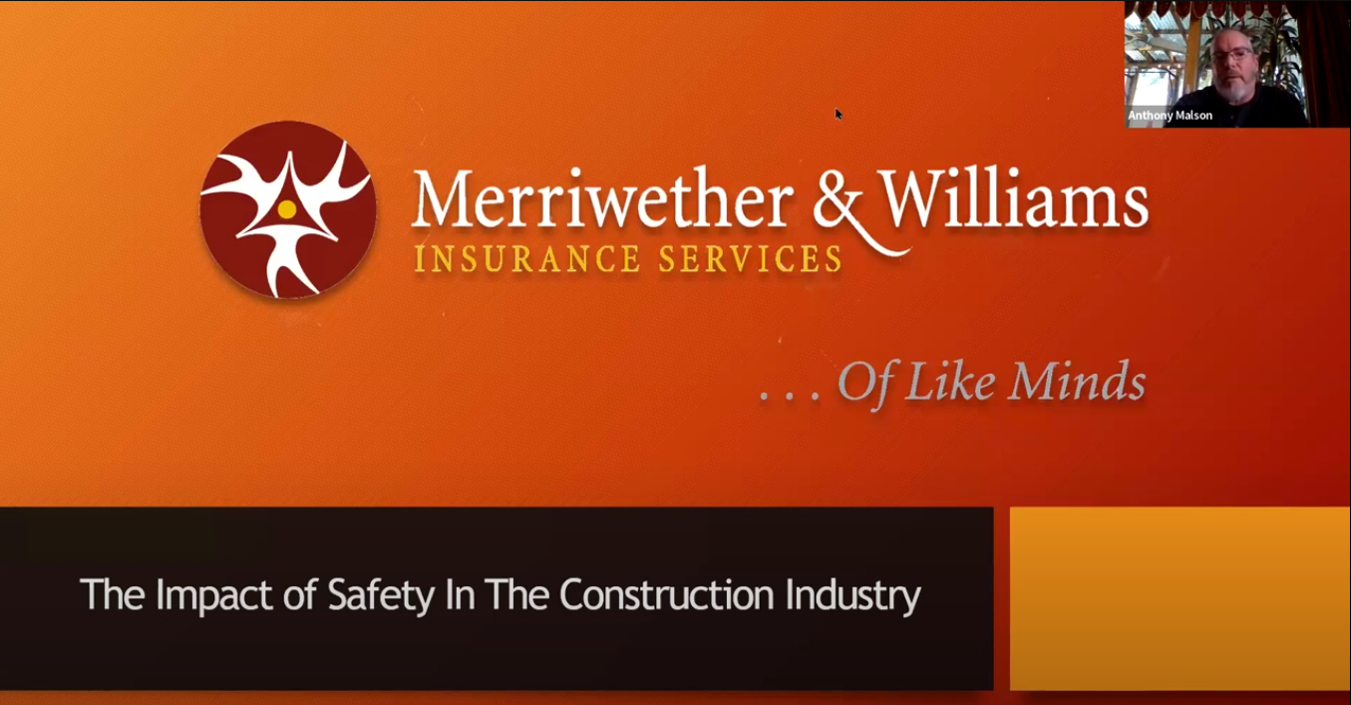

“There is always room for safety improvements within the construction industry. It is vital to keep up to date on the latest developments.” -- Anthony Malson, MWIS Safety Manager

This workshop was essential for construction managers, safety officers, site supervisors, project engineers, and anyone responsible for safety oversight on construction sites. Whether new to safety management or seeking to enhance existing skills, this workshop provided valuable insights and tools.

For construction contractors in Los Angeles, it is essential to equip oneself with the knowledge and tools to elevate safety standards in the construction industry. Together, we can build a safer future, where every construction site prioritizes the well-being of its workers and ensures compliance with the latest regulations.

To see a video recording of the safety webinar, click on the following link: https://youtu.be/MMCnjCa5mpE

