IN CASE YOU MISSED IT (ICYMI):
MWIS HOSTS WEBINAR ON “THE KEYS
TO CONTRACT NEGOTIATION AND REVIEW”

On June 5, Merriwether & Williams Insurance Services (MWIS) hosted a webinar entitled, “The Keys to Contract Negotiation and Review.” The topics covered included: clarification of expectations, insurance, scope management, quality assurance, payment terms, deliverables, risk management, regulation compliance, and dispute resolution. The webinar was offered through the Contractor Development and Bonding Programs (CDABPs) that MWIS, a Hub International Company, administers for its municipality clients.

Contract review and negotiation are crucial elements in the construction industry for several reasons. Construction projects are inherently risky due to factors such as delays, cost overruns, design changes, and unforeseen circumstances. Effective contract review and negotiation help allocate risks correctly among the parties involved, reducing the likelihood of disputes and litigations.

The topic of successful contract review and negotiation was addressed by Kirk Chamberlain, Executive Vice President, National Construction Practice Leader with HUB International. Mr. Chamberlain said, “We do that contract review to make sure that the risks you are being asked to take are reasonable, within your scope. and equitable.” He added that “We don’t want you to find yourself in a position where you are being asked to contractually take a risk that you cannot afford to take, you are not is a position to take and don’t have the resources to take. All that does is create a weak link in the chain.”

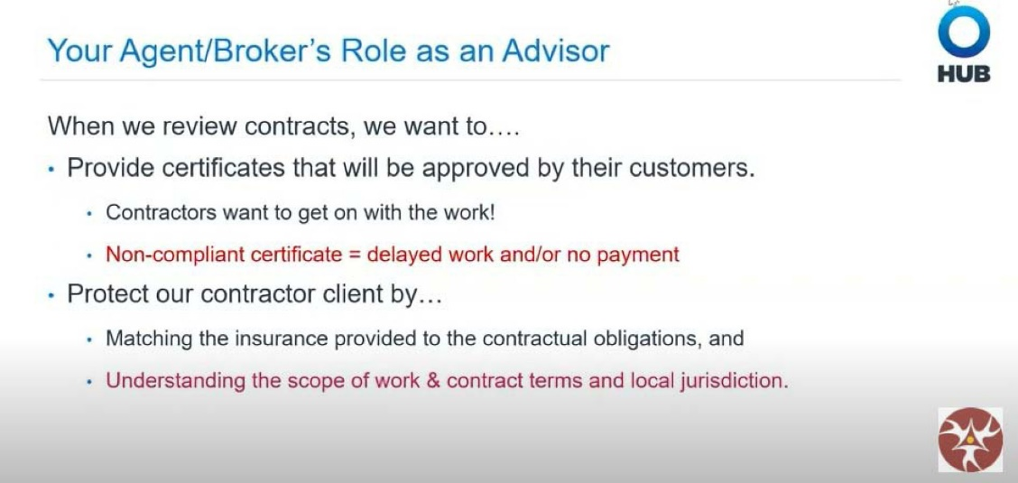
The broker’s role as an advisor to the contractor was outlined during the webinar.

Mr. Chamberlain also offered some tips and tricks when reviewing a contract. He said that contractors should pay close attention to AI language and ISO form edition dates or non-standard terms, understand relevant state/jurisdiction statues of repose and anti-indemnity laws, watch out for limitations of liability, and utilize the “search and find” tool with PDF files.

Each stakeholder has different contractual interest and abilities to share risk, but all share a common contractual framework and end game, said Mr. Chamberlain.
“The first thing we need to understand is who are the counter parties on the contract and who do we represent because each party has a slightly different interest in the contract negotiation phase,” said Mr. Chamberlain. “All of the stakeholders are part of the conversation—the project owner/developer, general contractor, subcontractor, vendor, etc.”

There is also a difference depending on who your client is, said Mr. Chamberlain. The insurance requirements are going to be baked into the contract documents, he said. For instance, public owners/publicly funded work features contract requirements and insurance requirements that are fixed, inflexible, and leave little room for negotiation, and typically require surety bonding. With private owners/privately funded work, however, contract requirements and formats vary widely, sometimes flexible, often negotiable, and may or may not require surety bonding.

Mr. Chamberlain also outlined the importance of a certificate of insurance in the contract review and negotiation process. “A certificate of insurance is a shorthand list of the services you have agreed to in your contract to provide your upstream partner, and it should match up with the indemnity as well,” he said. “It will list all of the relevant information to ensure that you are complying with their requirements. It is not a legally enforceable document or a complete substitute for insurance policy documents.”

Every complete contract should include both indemnity provisions and insurance provisions, Mr. Chamberlain said. Those provisions should fit seamlessly, and the provisions should not include contradictory language, he said. He added that insurance provisions should be very specific, and that choice of language is important to avoid any confusion regarding who is assuming risk.

“As a contractor, your main job is managing risks,” Mr. Chamberlain said. “You have to figure out if you can do the work safely and if you can do it competitively. You can eliminate or mitigate risk and associated costs by understanding contract language and the scope of work. You also need to identify and negotiate equitable language in upstream and downstream contracts to minimize the cost of defending and indemnifying the liability of others.”

Mr. Chamberlain advised contractors to analyze and understand “risk vs. reward” in contracts by limiting risk via indemnity and limitation of liability, and to allocate risk downstream to the subcontractors or vendors, where appropriate.

The full video, titled “The Keys to Contract Negotiations and Review,” may be viewed here. The website for HUB International is https://www.hubinternational.com/ and the website for Merriwether & Williams is https://imwis.com/.

