MWIS TRAINS CONTRACTORS ON HOW TO MANAGE CONSTRUCTION CONTRACTS FROM PROJECT AWARD TO CLOSE-OUT

Merriwether & Williams Insurance Services (MWIS) hosted a training academy entitled, “2024 Contract Award & Management Hybrid Training Academy”, that aimed to teach small, local, and diverse contractors how to manage construction projects from award through close-out. The academy class met once a week for six weeks from September 10 through October 15. The academy is a component of the Los Angeles Regional Contractor Development and Bonding Program (CDABP), which MWIS, a Hub International Company, administers on behalf of the City of Los Angeles, LA Metro, and the County of Los Angeles.  
   
MWIS’s Robert Lowery, Field Support Project Executive, kicked off the training academy by giving a detailed overview of the principles of contract award and management. The training program featured a range of expert speakers from the City of LA, the County of LA, and LA Metro.  Notable construction-related firms such as Lanak & Hanna, PCL Construction, Swinerton Builders, and Austin Industries also provided best practices, lessons learned, and their overall valuable experience and expertise.

Week 1 was followed by a two-part presentation by Colin McCarthy, principal attorney for Lanak & Hanna, a construction-centric law firm, who educated attendees about the nuances of construction contracts. Drawing on his extensive expertise, Mr. McCarthy provided real-world examples of common construction pitfalls that contractors experience during public works contracting.

PCL Construction provided an in-depth overview of the fundamentals of project management in the construction space that are needed to drive a project to its completion. Stressing the value of quality, consistency, and organization, Swinerton Builders gave a presentation on quality control and construction scheduling. Closing out the training academy, Austin Industries spoke about the value of understanding and managing overhead and other construction costs when closing out projects.

Academy graduates display their certificates of completion and

bobblehead gifts. Pictured with them are Keith Compton, standing far left,

Director of Capacity Building, Data Integration, and Small Business

Outreach, LA Metro; Janet Maza, right of Mr. Compton, Senior Project

Manager, Austin Industries; Lynda McGlinchey, standing far right,

Compliance Program Manager II, Department of Public Works,

City of Los Angeles.

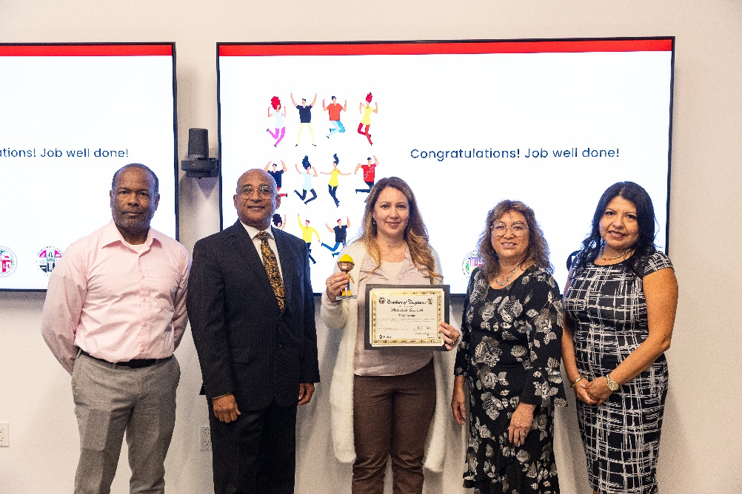

Marlena Burton, owner and CEO of TRMJ Roofing

displays her graduation certificate. Pictured left to right,

are Robert Lowery, Field Support Project Executive, MWIS;

Keith Compton, Director of Capacity Building, Data Integration,

and Small Business Outreach, LA Metro; Ms. Burton;

Lynda McGlinchey, Compliance Program Manager II,

Department of Public Works, City of Los Angeles;

Rosa Osorio, Assistant Program Manager, MWIS.

Participant Marlena Burton, owner and CEO of TRMJ Roofing, said, “My experience with the academy has opened my mind and eyes to explore different avenues. It has educated and empowered me to do hard things. I strongly suggest that people take the time to sign up and enroll in this program because there’s so much opportunity there. It has empowered me to want to build and create opportunities for employment and build our company. Thank you very much.”

The academy’s hybrid format of in-person and virtual training sessions and practical project-based approach was a valuable resource for contractors looking to enhance their skills, collaborate with other professionals, and stay current with industry trends.

Marcus Savage, owner and CEO of Savage Construction,

displays his graduation certificate. Pictured left to right

are Robert Lowery, Keith Compton, Mr. Savage,

Lynda McGlinchey, and Rosa Osorio.

Another graduate was Marcus Savage, owner and CEO of Savage Construction. Mr. Savage said, “I believe the academy gives contractors valuable information that helps the bottom line and helps us avoid some of the barriers and pitfalls contractors face from the beginning to the end of the process.”

“New knowledge gained from the academy will enable contractors to grow their businesses, increase their capacities, and allow them to fully take advantage of the public works construction opportunities in the LA region,” said MWIS’s Mr. Lowery.

The LA Regional Contractor Development and Bonding Program is here to help small, local, and diverse contractors build their capacities and access construction contracts with municipalities. For more information on the CDABP, whose services are offered at no cost to contractors, visit the following website: [www.LAConDev.com](https://imwiscom-my.sharepoint.com/personal/ryordanos_imwis_com/Documents/www.LAConDev.com).