LA METRO CO-HOSTS SEMINAR WITH MWIS ON
CONTRACT FINANCING ASSISTANCE PROGRAM

On April 29, LA Metro co-hosted a seminar as part of the LA Regional Contractor Development and Bonding Program (CDABP), which Merriwether & Williams Insurance Services (MWIS) administers on behalf of LA Metro, the County of Los Angeles, and the City of Los Angeles. The seminar provided an overview of the Contract Financing Assistance Program (CFAP), which is a component of the CDABP.

One of the critical challenges for small and diverse contractors in participating in public agency projects is the delay between commencing work and receiving initial payment. The CFAP addresses this challenge and is designed to assist contractors in navigating and accessing capital. The goal of the workshop was to provide contractors with the necessary resources to obtain contracts with Metro, providing real-time examples of contract opportunities.

The event presenters included Keith Compton, Director of Capacity Building & Data Integration,
Diversity & Economic Opportunity Department, LA Metro, and John Miller, Contract Base Project Manager, MWIS.

The workshop provided a detailed overview of the program, emphasizing the practicality of the content and how it can be directly applied to the contractors' projects. The seminar highlighted the significance of securing cash flow and the valuable skills and tools that contractors can acquire throughout the process. The workshop aimed to encourage contractors to get prequalified and identify Metro projects, providing them with actionable steps to improve their project management and financial planning.

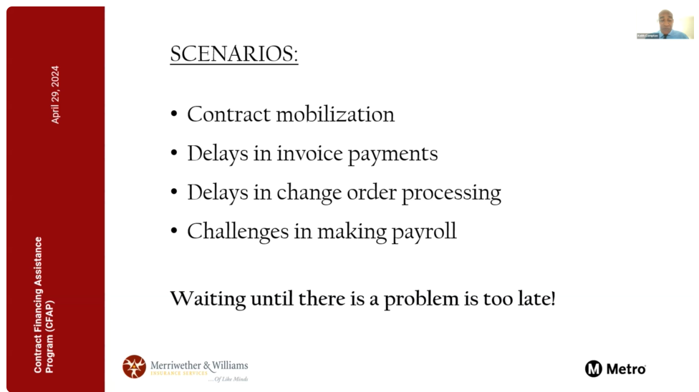

“We want you to get prequalified and have this resource to help you when you need it.”

Keith Compton, Director of Capacity Building & Data Integration,
Diversity & Economic Opportunity Department, LA Metro

The seminar explained cash flow projection as a fundamental tool for determining existing cash resources, the cash required for project implementation, the potential need for a CFAP loan to fund the work, projected income from the project, and the anticipated ending cash position. The goal was to emphasize the importance of understanding their financial position at the onset of a project, during construction, and post-construction, equipping small construction contractors with the necessary information to manage a project to successful completion.

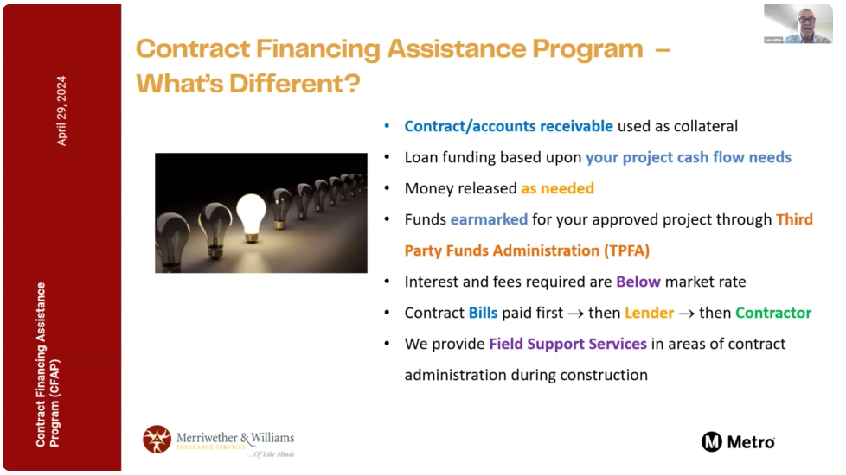
“ We are using you contract proceeds as collateral.”

John Miller, Contract Base Project Manager, Merriwether & Wiliams Insurance Services

The seminar also strongly emphasized the importance of proactive prequalification. By being loan-ready when the next contract is awarded, contractors can seize opportunities more effectively and increase their chances of securing contracts. This proactive approach is a key strategy for success in the competitive public agency projects arena.

