IN CASE YOU MISSED IT (ICYMI):
LA METRO AND MWIS CO-HOST WORKSHOP AIMED AT HELPING
DISABLED VETERAN BUSINESS ENTERPRISES

On August 22, Los Angeles Metro and Merriwether & Williams Insurance Services (MWIS) co-hosted the annual “Connecting with Metro for Disabled Veteran Business Enterprises” workshop. The hour-long virtual workshop was packed with information to enable DVBEs to grow their bonding capacity as well as provide information and resources to expand their business. The workshop is a component of the LA Regional Contractor Development and Bonding Program (CDABP), which is administered by MWIS, a Hub International Company.

Jan Davis, LA Metro Senior Representative, Diversity and Economic Opportunity (DEOD), shared the process of how to enroll with Metro. She said, “Get certified. Metro recognizes certification from the state of California.” Ms. Davis provided attendees with the following link: https://bit.ly/3TmMqrY

Carlos Ray, MWIS Assistant Client and Community Relations Manager, detailed the role of bonding and how a higher bonding capacity enables DVBEs to pursue and win large contracts. Mr. Ray said, “MWIS offers many contractor development services and programs, including contract technical assistance, contract financing, bid document review, and contract award support.”



“MWIS offers many contractor development
services and programs.”

Carlos Ray, MWIS Assistant Client and Community Relations Manager

Guillermo Casillas, principal owner of Rushmore Construction Company, shared his experience as a current program participant of CDABP. Ms. Casillas, a former U.S. Army paratrooper, said the CDABP helped him to bid for larger projects with assistance from the Contract Finance Assistance Program (CFAP), and it also allowed him to improve his cash flow.

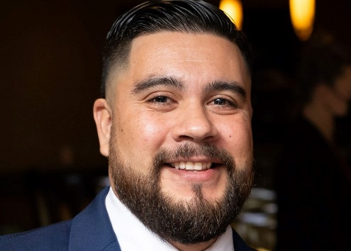

“The CDABP is a great one-stop approach
and helped us by providing many resources.”

-- Guillermo Casillas, Principal Owner, Rushmore Construction Company

“The CDABP is a great one-stop approach and helped us by providing many resources. Discipline and self-motivation are great skills that veterans possess to run a construction business.”

The final speaker was Anthony Williams with the National Association of Black Veterans, better known as NABVets, and he stressed the importance of getting certified and bonded.

The LA Regional CDABP offers, at no cost to contractors, many industry-leading educational programs that reduce the barriers of bonding/capacity, enabling greater and successful participation of small, local, minority, women, and disabled veteran-owned businesses in public contract opportunities. For more information, visit https://www.lacondev.com/

To view a recording of the workshop, visit https://www.youtube.com/watch?v=9LSyzFbEQHg

