MWIS HOSTS WORKSHOP ON

“MASTERING YOUR JOB START UP IN THE CONSTRUCTION INDUSTRY”

On July 23-24, Merriwether & Williams Insurance Services (MWIS) hosted a two-day in-person training workshop entitled, “Mastering Your Job Start Up in the Construction Industry.” The training aimed to equip contractors with the necessary skills, knowledge, and confidence to start any construction project. The workshop is a component of the Los Angeles Regional Contractor Development and Bonding Program (CDABP), which MWIS administers on behalf of the City of Los Angeles, LA Metro, and the County of Los Angeles.

Topics covered during the two-day training included: preliminary notices, change orders, injury and illness prevention programs, safety, job hazard analysis, site visits, payments, and requests for information, amongst other vital considerations when starting a construction project. Robert Lowery, Field Support Project Executive at MWIS, presented the training.

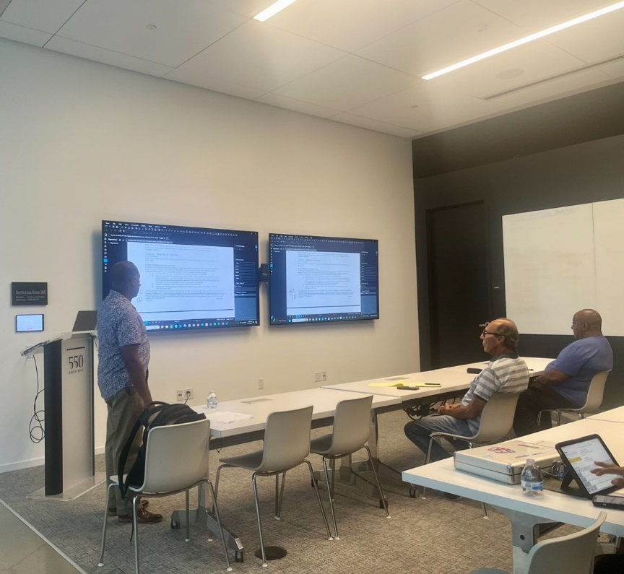

*Robert Lowery, Field Support Project Executive at MWIS,*

*shown leading the two-day workshop*

One attendee, Samuel Hernandez-Cruz, owner and CEO of SPD Electric Corp, spoke on his experience, stating, “I was so happy I meet everyone in this program. If you’re a contractor that doesn’t have any experience or does not know where to start, this program will set you up for success. I am so excited to start my journey with them. All the help that I am getting from them, there is no price for it. I truly recommend it.”

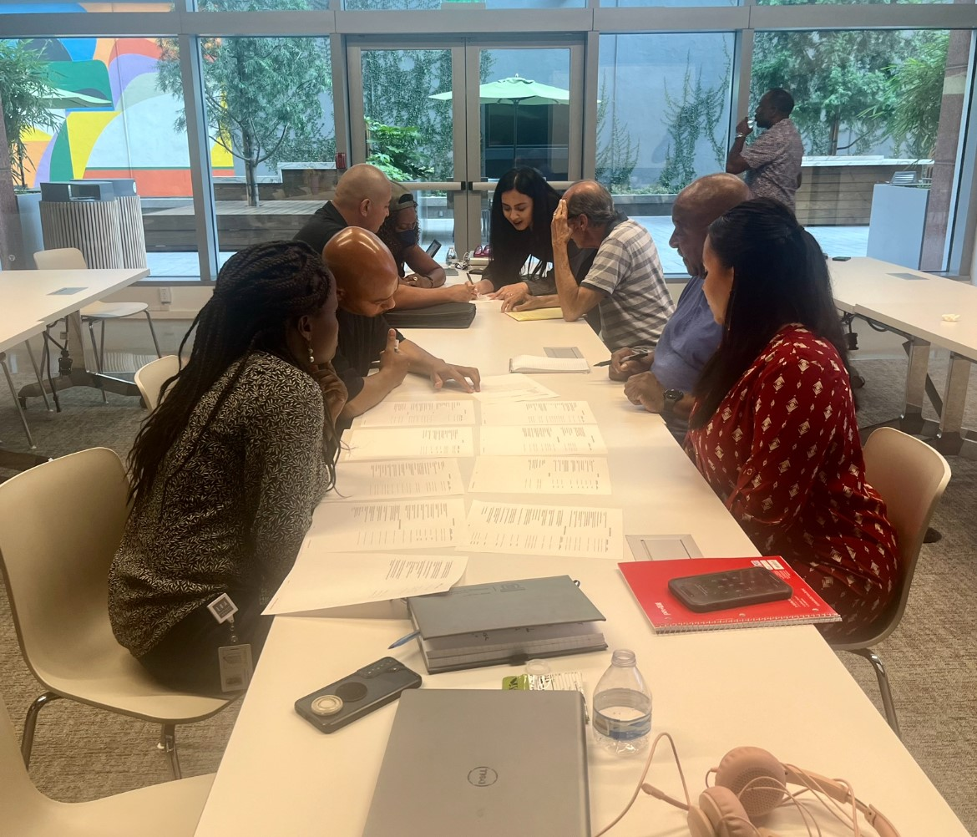

*As part of the workshop, attendees participated*

*in group activities with MWIS staff*

The workshop underscored the value of an organized and transparent approach when taking on any new project. Further, an interactive portion of the training allowed the contractors to review a job start checklist alongside MWIS’s Contractor Development Managers.

Owner and CEO of Kebeco Construction Services Inc, Kenneth Collins Sr., was another participant who reflected on his experience, stating, “I really appreciated the training, especially our host and instructor. But also, the experience of all the other MWIS trainers that were available, who allowed their knowledge to be given to us. I look forward to continuing classes throughout the year and getting my first contract with the City or the County of Los Angeles.”

Contractors acquired significant knowledge and built new connections by networking with other small and diverse construction firms. Participants recognize that the knowledge gained from their time and effort in the training will support business growth, enhance capacity, and improve their ability to take advantage of public works opportunities.

For more information on the LA Regional CDABP and future training sessions, visit our website at [LAConDev.com](https://www.lacondev.com/).