MWIS TRAINS CONSTRUCTION CONTRACTORS ON HOW TO GET CONTRACT READY WITH THE COUNTY OF LOS ANGELES

Merriwether & Williams Insurance Services (MWIS) co-hosted a three-week virtual training series entitled, “Get Contract Ready with the County of Los Angeles,” which ran from August 14-28. Co-hosted with the County Department of Economic Opportunity (DEO), the academy aimed to prepare contractors for opportunities with LA County, and it also highlighted the no-cost business and workforce services offered by the DEO. The academy is a component of the LA Regional Contractor Development and Bonding Program (CDABP), which MWIS, a Hub International Company, administers on behalf of LA County, LA Metro, and the City of Los Angeles.

The academy had an array of speakers from the LA County Department of Public Works (DPW), Internal Services Department (ISD), and the DEO’s Office of Small Business (OSB). Topics covered included registration, navigation and searching for projects, types of certifications, how to certify, identification of different procurement types, and resources provided by the APEX Accelerator Program. The speakers went in-depth on the topics and their relevance to contractors looking to do business with LA County and beyond.

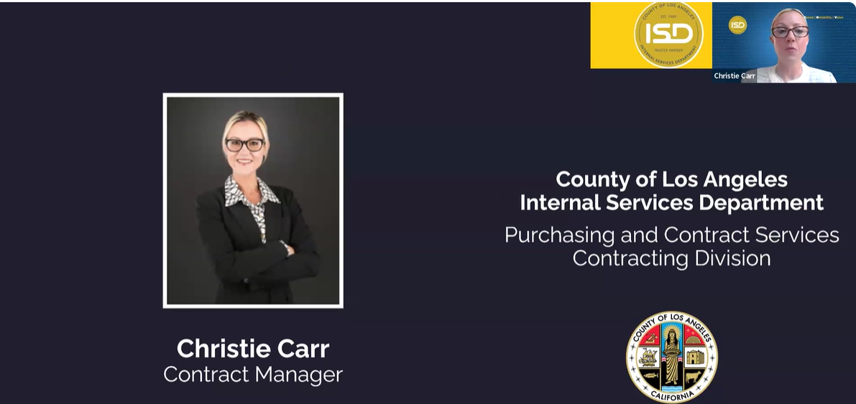

Christie Carr, Division Manager, County ISD, discussed the importance
of registration and described the step-by-step process of how to register.

Week 1 of the training series set the foundation for what contractors would learn about doing business with the County of Los Angeles. Karla Talisse, Contractor Development Manager at MWIS, started the session with an overview of the CDABP program and the services and resources available to contractors. She expanded on the benefits offered through the program, including technical assistance, bonding, and training services. Christie Carr, Division Manager, County ISD, gave a presentation to contractors covering vendor registration. In her presentation, she discussed the importance of registration and described the step-by-step process of how to register.

Week 2 of the training session included presentations outlining information about the types of certifications available with LA County and the procurement types the County uses in its contracting opportunities. Speakers also explained how to identify them and how to do business with the DPW, including the specifics on Job Order Contracts (JOC) and Bid Form Packages. Shuli Alvarez, a Small Business Counselor from the DEO OSB, provided an in-depth presentation about the certification process, what distinct types of certifications are offered, and small business counseling services offered by the DEO. In addition, Angelica Mosley from the County DPW gave an insightful presentation on the procurement process, JOCs, Best Value, Requests for Proposals (RFPs), Invitations for Bid (IFBs), and Requests for Qualifications (RFQs).

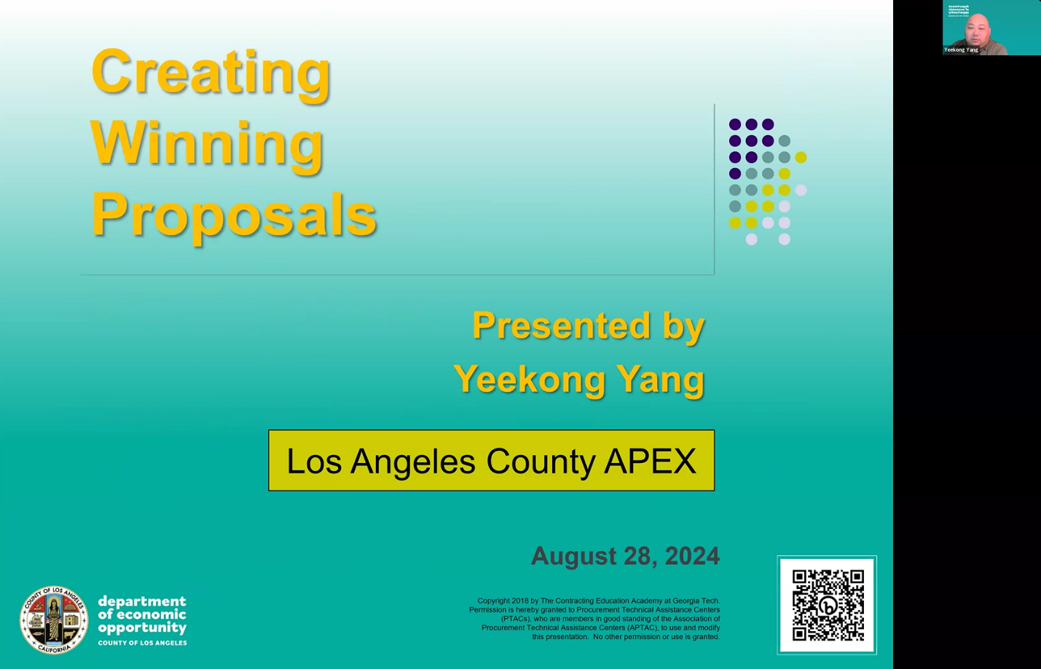

Yeekong Yang, APEX Accelerator Program Counselor from the
Department of Economic Opportunity’s Office of Small Business,
gave insights on how to create winning proposals

Closing out the training series, the final week featured a presentation about creating winning proposals offered by the DEO and the APEX Accelerator Program. The APEX Accelerator Program provides technical assistance to businesses interested in selling products or services to federal, state, and local governments.

Attendee Erika Velasquez of Prime Point Contracting reflected on her experience, stating, “I attended the academy, and I learned the steps needed to be able to be ready! From learning about bonding, to reviewing bid docs, and registering with LA County DPW, I highly recommend attending this academy! It is FREE knowledge and resources given to you. All you need to do is apply them to your business if you would like to be out there bidding on projects!”

David Garcia, owner of DG Prime Solutions, said, “Attending the academy was a game-changer for me. The expert speakers provided practical tips and strategies that have already improved my contract management process.”

To sign up for counseling sessions with the County DEO OSB, click here.

For more information on upcoming training academies and other CDABP services, contact MWIS by calling 213-258-3000, sending an email via mwisinfo@imwis.com, or going online at www.LAConDev.com.

