IN CASE YOU MISSED IT (ICYMI):
LA CITY COUNCILMEMBER MONICA RODRIGUEZ HOSTS A WORKSHOP
WITH MWIS ON INFRASTRUCTURE CONSTRUCTION OPPORTUNITIES

On May 9, 2024, Los Angeles City Councilwoman Monica Rodriguez, who represents District 7, co-hosted a virtual workshop entitled, "Navigating LA City Contracting Opportunities," with Merriwether & Williams Insurance Services (MWIS). During this workshop, contractors learned about the LA Regional Contract Development and Bonding Program (CDABP), which MWIS administers on behalf of the City of Los Angeles, LA Metro, and the County of Los Angeles.

Councilwoman Rodriguez’s chief of staff, Marie Rumsey, warmly welcomed the contractors in attendance. Ms. Rumsey motivated the attendees to realize their full potential and pursue opportunities as city contractors. She emphasized that these efforts not only benefit individuals personally but also play a crucial role in the city's overall well-being. Ms. Rumsey said, "My hope at the end of this is that you will be able to maximize your potential, become a city contractor for your own benefit, and also play a critical role in this city’s continued recovery from COVID.”

The workshop featured presentations from representatives of Los Angeles World Airports (LAWA), the Public Works Bureau of Contract Administration (BCA), and the Port of Los Angeles (POLA) about upcoming construction opportunities.

Before these informative sessions, attendees were inspired by a brief interview featuring Jacqueline Pruitt, President and CEO of Marvella Steel Placers. Her story offered valuable insights and served as a beacon of hope, illustrating the potential heights that can be reached with the right support and guidance. Ms. Pruitt said, “The program has been instrumental in providing seminar workshops and training … It has been very helpful in the growth and development of my company.”

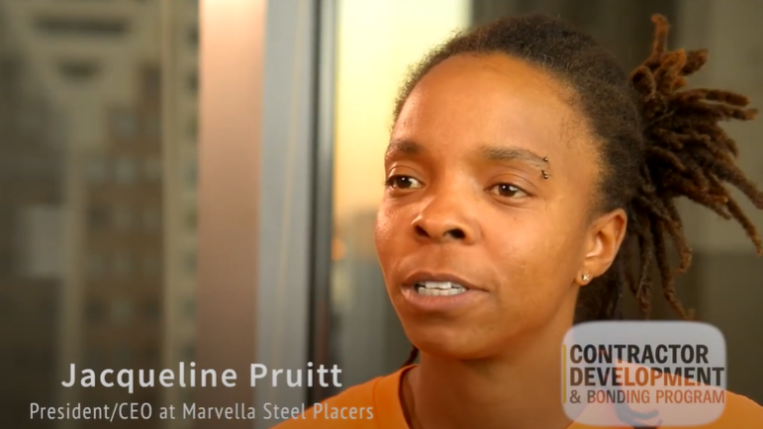

“The program has been instrumental in providing seminar workshops and training … It has been very helpful in the growth and development of my company.”

Jacqueline Pruitt, President and CEO, Marvella Steel Placers

The CDABP is a contractor support initiative that promotes the growth of small, local, and diverse businesses, and contractors are encouraged to utilize its services, which are offered at no cost to them. These services include bonding, financial assistance, and technical assistance. More information on the program can be found on the LA Regional CDABP website: www.LAConDev.com.

