IN CASE YOU MISSED IT (ICYMI):
MWIS HOSTS WORKSHOP ON
“HOW TO SUCCEED AT BIDDING AND ESTIMATING”

On April 30, Merriwether & Williams Insurance Services (MWIS) hosted a workshop entitled, “How to Succeed at Bidding and Estimating,” which was led by Robert Lowery, Field Support Project Executive at MWIS. The workshop covered a variety of topics, including delivery models, types of bidding and estimating software, how to set up and estimate, how to determine your costs, insurance and bonds needed, and pricing.

The process of bidding and estimating are essential elements of the construction industry for several reasons. Accurate estimation helps to control costs throughout the project lifecycle and the right estimation ensures that the project is completed within the budget and timeline agreed upon with the client. Bidding allows contractors to compete for projects, and accurate estimates give them a competitive advantage in winning contracts by presenting competitive and realistic pricing.
“People often get bidding and estimating confused,” said Lowery. “Your estimate goes into your bid packet and the estimate is separate. Bidding is actually the process of providing a potential customer with a proposal to build or manage the building of a structure. It’s also the method by which contractors pitch their services to general contractors.”

Lowery also pointed out that there are three major decisions that shape construction bidding. The owner must decide on the elements of the project delivery method, a procurement method, and a contract type.
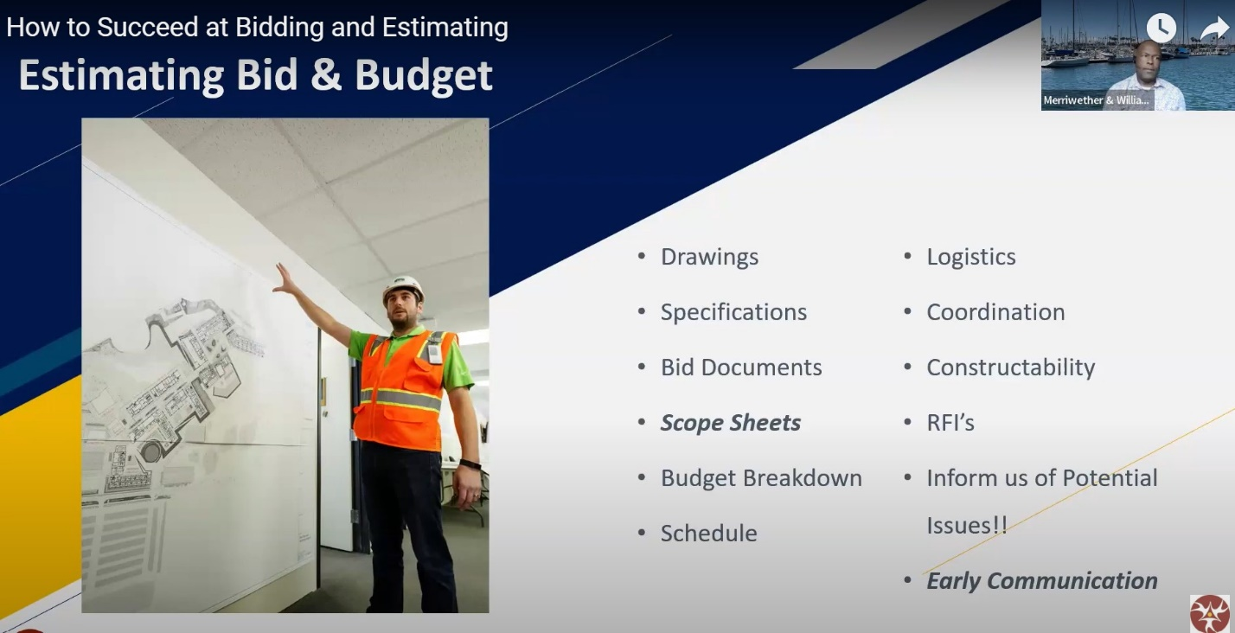
“Estimating is both a science and an art,” said Robert Lowery, the webinar lead presenter and Field Support Project Executive at MWIS.
According to Lowery, estimating is both a science and an art because it involves both intrinsic and learned skills, and it involves risk. It is the estimator’s responsibility to recognize both risk and opportunity, and the estimator should realistically, coherently, and comprehensively evaluate and communicate them, he added.
There are several components that also need to be considered when putting together an estimating bid and budget, said Lowery. These details include: drawings, specifications, bid documents, scope sheets, budget breakdown, schedule, logistics, coordination, constructability, RFIs, and early communication.
“Take a close look at what is included in the bid documents,” said Lowery. “Public works projects have certain forms that need to be filled out. With these forms, we can review your bid documents prior to submitting them. Do not leave anything blank. If it does not apply to you, mark it ‘N/A.’ Also make sure it’s signed and/or notarized. If you forget something, you will be considered non-responsive.”

Lowery also discussed how a contactor can increase their chances to win the bid. It is crucial that the bidding party provides budgetary pricing, completes the scope sheet, meets all deadlines, attends job walks, provides value engineering (VE) ideas, and openly communicates throughout the process.
“Value engineering ideas can be an increase or decrease in costs,” he said. “When you do the VE, you want to say that this product I am proposing to you is equal or better, but it costs less. In other words, this brand is cheaper, but it still meets the specs.”
The importance of “takeoff” was also covered in the webinar. In construction, a takeoff is the process where contractors determine how much of each material they will need to complete a project, and is a significant step in estimating accurate project costs.
“It’s the foundation of all estimates,” added Lowery. “The estimate is only as good as the takeoff because if the takeoff is wrong, the estimate will be wrong. You need to check quantity and estimates before you start putting it all together.”
Some of the tools for bidding and estimating recommended by Lowery include Microsoft Excel, Project, RS Means, Bluebeam, Autodesk, and PlanGrid, P6, and Monday.com.
The full “How to Succeed in Bidding and Estimating” webinar may be viewed here.

