IN CASE YOU MISSED IT (ICYMI):
LA COUNTY SUPERVISOR AND METRO BOARD MEMBER HOLLY J. MITCHELL HOSTS A WORKSHOP WITH MWIS ON
INFRASTRUCTURE CONSTRUCTION OPPORTUNITIES

On February 2, 2024, the office of Los Angeles County Supervisor and LA Metro Board Member Holly J. Mitchell co-hosted a virtual workshop entitled, "Navigating LA County and Metro Contracting Opportunities," with Merriwether & Williams Insurance Services (MWIS). During this workshop, contractors learned about the LA Regional Contract Development and Bonding Program (CDABP), which MWIS administers on behalf of the County of Los Angeles, LA Metro, and the City of Los Angeles. Attendees learned about certifications, small business programs, the procurement process, and upcoming construction opportunities from LA Metro, and Los Angeles County’s departments of Public Works (DPW) and Internal Services Department (ISD). Attendees also learned about the Equity in Infrastructure Project (EIP) Pledge that LA County signed.

Supervisor Mitchell is a strong advocate for small and diverse businesses, and she is taking steps to ensure that these contractors thrive in the construction industry. Recently, at the LA Infrastructure Forum, Supervisor Mitchell signed the EIP Pledge on behalf of LA County, joined by more than a dozen other municipalities that also signed the EIP Pledge. The purpose of this pledge and of EIP is to reduce the wealth gap and build generational wealth by improving public infrastructure contracting practices. Specifically, the EIP Pledge commits signatories to increase the number, size, and percentage of Historically Underutilized Businesses (HUBs) that grow to become prime contractors, participate in joint ventures, or become equity participants.

During the webinar, Caroline Torosis, Senior Deputy of Workforce Development & Economic Opportunity for Supervisor Mitchell, gave a warm welcome and discussed the actions that the Supervisor is taking to ensure opportunities for small and diverse firms. In addition to committing to tripling the number of certified small businesses in LA and establishing a $2 million revolving loan fund to help with start-up costs, the Supervisor codified a 25% utilization rate for small businesses. Furthermore, she created a small network of small business advocates within each county department to achieve these utilization goals. "We're doing all of this with an eye towards outcomes, towards impact," said Ms. Torosis. "Please know that you have an advocate in our office."

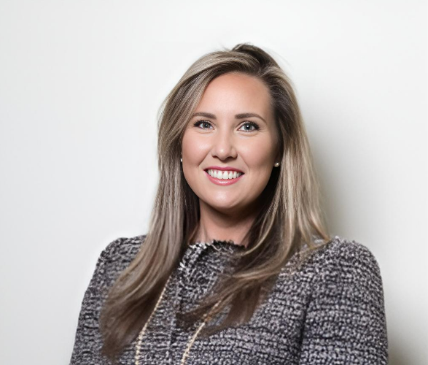

“We’re doing all of this with an eye towards outcomes, towards impact.”

-- Caroline Torosis, Senior Deputy, Workforce Development & Economic Opportunity, Office of LA County Supervisor and LA Metro Board Member Holly J. Mitchell

Webinar attendees were shown a news segment that ran on KTTV-TV Channel 11. The news clip highlighted the success of two contractors who took advantage of the CDABP program and won public contracts. The firms were Fixed Dimensions and PG Cutting Services. Juan Garcia, the CEO of PG Cutting Services, and Adam and Bethany White, the owners of Fixed Dimensions, talked with show host Hal Eisner about how the CDABP helped their businesses compete with larger businesses. Mr. Eisner asked, “How effective has [the CDABP] been for you?” Mr. Garcia responded by saying, “Very effective… You feel this sense of support when you’re bidding on something. In fact, right now, I’m bidding on a big project in a week or two with LA Metro, and I need more bonding for this project, so we already have the wheels in motion. Without that, I would be a little lost.”

The KTTV segment demonstrated in human terms what the CDABP is about. It underscored how essential bonding is in public procurement. Thanks to the CDABP, a number of small and diverse contractors can now enhance their bonding capacity, fulfill the prerequisites of public contracting, and compete with larger businesses that have traditionally dominated the industry.

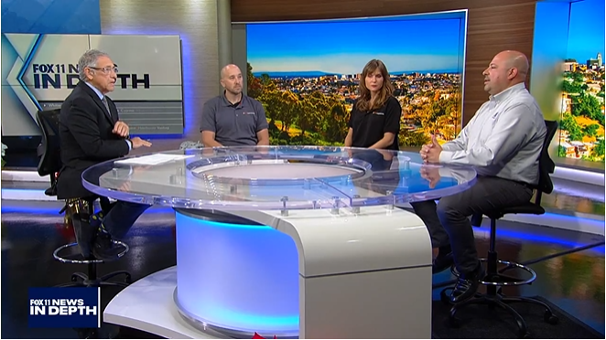

“You feel this sense of support when you’re bidding.”

-- Juan Garcia, CEO, PG Cutting Services

The CDABP is a contractor support initiative that promotes the growth of small, local, and diverse businesses, and contractors are encouraged to utilize its services, which are offered at no cost to them. More information on the program can be found on the CDABP website: www.LAConDev.com.

