MWIS HOSTS A 2 DAY TRAINING WORKSHOP ON

CERTIFIED PAYROLL AND LABOR COMPLIANCE

On June 10 and June 11, Merriwether and Williams Insurance Services (MWIS) hosted a 2-day training workshop on certified payroll and labor compliance as part of the LA Regional Contractor Development and Bonding Program (CDABP), which MWIS administers on behalf of LA Metro, the County of Los Angeles, and the City of Los Angeles. Certified payroll and labor compliance are crucial aspects of construction contracting, ensuring adherence to labor laws and fair compensation practices for workers.

The goal of the workshop was to provide contractors with the necessary resources to obtain and maintain detailed records for each worker, documenting their hours worked, wages paid, fringe benefits provided, and any deductions made. Labor compliance extends beyond payroll records to encompass broader regulatory requirements concerning worker classification, safety standards, and equal employment opportunities. The event presenter was Veronica Avila, principal of Labor Compliance Enterprise.

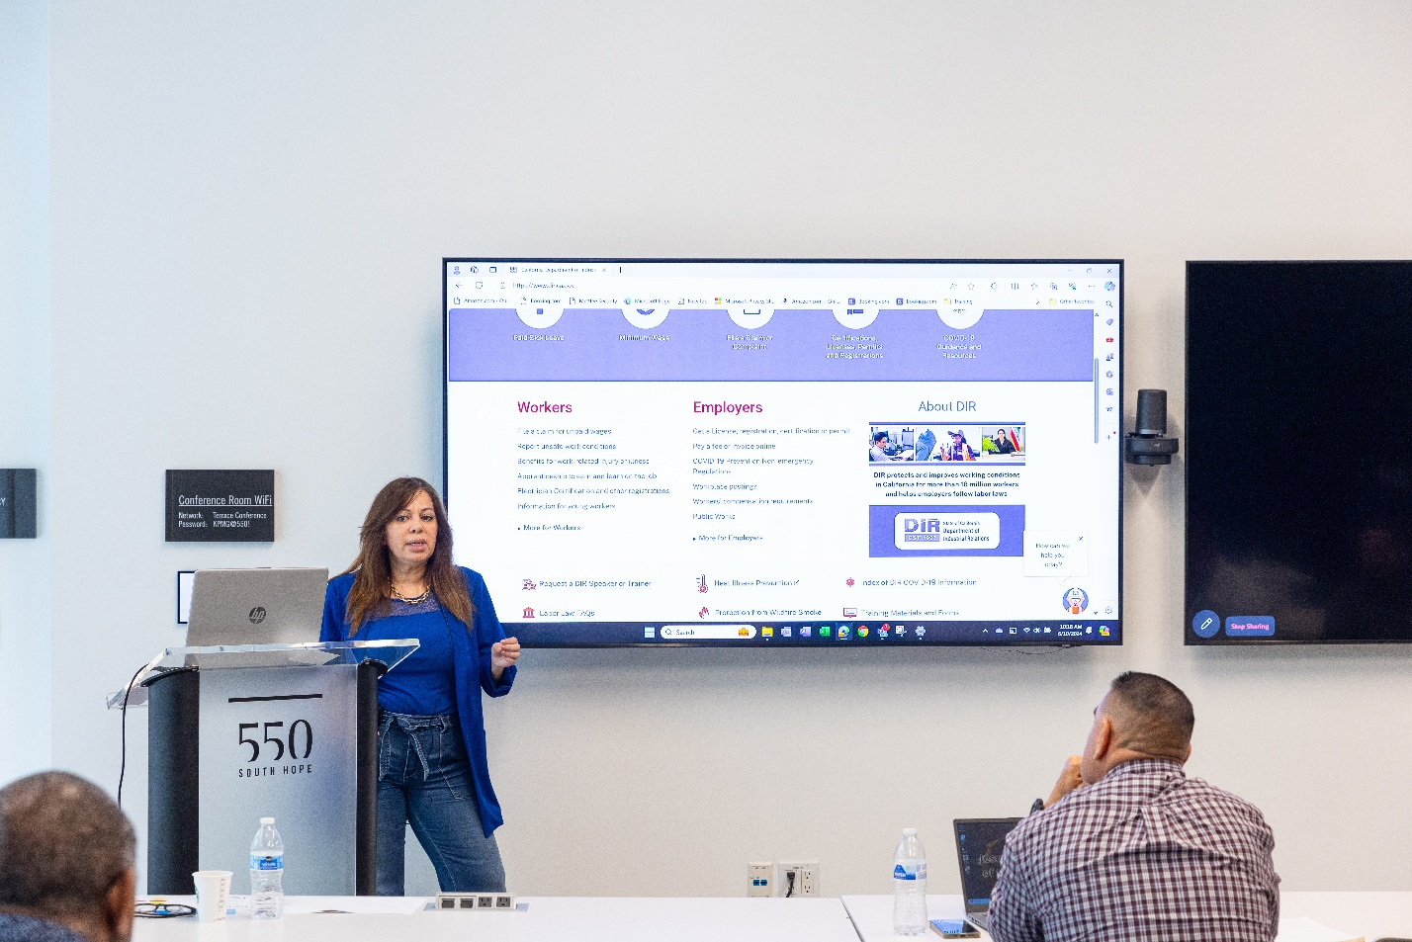

“We want leave you with as much information, tools and resources that you can go back and look at afterwards.” -- Veronica Avila, principal of Labor Compliance Enterprise

The workshop guided contractors through the essential requirements and best practices to ensure their construction projects are compliant with local, state, and federal labor laws. The goal was to emphasize the importance of understanding certified payroll and labor compliance for contractors to maintain regulatory requirements and to uphold ethical standards that benefit both the contractors’ business and their workforce. Ms. Avila said, “We want leave you with as much information, tools and resources that you can go back and look at afterwards.”



“The workshop did a great job of showcasing the lay of the land for what to expect while working on public works projects.” - Jose Thomas, owner of Thomas Land Clearing Company

Students were shown how to properly delegate their labor resources and comply with union labor and apprentice requirements, while understanding the importance of proper record-keeping. Attendee Jose Thomas, owner of Thomas Land Clearing Company, who has benefited from the CDABP, said that a key takeaway for him was learning about the potential pitfalls of being non-compliant -- it can be very costly, lead to disbarment from public works agencies, and even result in civil or criminal penalties.

For construction contractors in Los Angeles, staying compliant with certified payroll and labor regulations is not just a legal obligation but a critical aspect of maintaining business integrity and reputation. The training webinar conveyed that failure to comply can lead to severe consequences, including fines, project delays, and legal disputes. Therefore, contractors often invest in robust payroll systems and legal counsel to navigate the complexities of labor compliance effectively.

Mr. Thomas said the workshop was worthwhile. He stated, “The workshop did a great job of showcasing the lay of the land for what to expect while working on public works projects.”