IN CASE YOU MISSED IT (ICYMI):

MWIS HOSTS FIVE-WEEK ACADEMY ON CONSTRUCTION BIDDING

AND ESTIMATING FOR CITY OF LOS ANGELES PROJECTS

Merriwether & Williams Insurance Services (MWIS) hosted a five-week “Construction Bidding & Estimating Training Academy” designed to help small, local, and diverse contractors develop and improve their estimating skills when bidding on public works projects with the City of Los Angeles. The academy, which concluded on March 19, is part of the Los Angeles Regional Contractor Development and Bonding Program (CDABP), which MWIS administers for the City of Los Angeles, Los Angeles Metro, and the County of Los Angeles.

The training program featured a range of expert speakers from the City of Los Angeles and notable construction companies such as Clark Construction, Hathaway Dinwiddie, Hensel Phelps, and Whiting-Turner. The speakers presented on various topics surrounding bidding and estimating, sharing their industry insights, experiences, and knowledge of best practices to attendees, 18 of whom graduated and received certificates of completion.

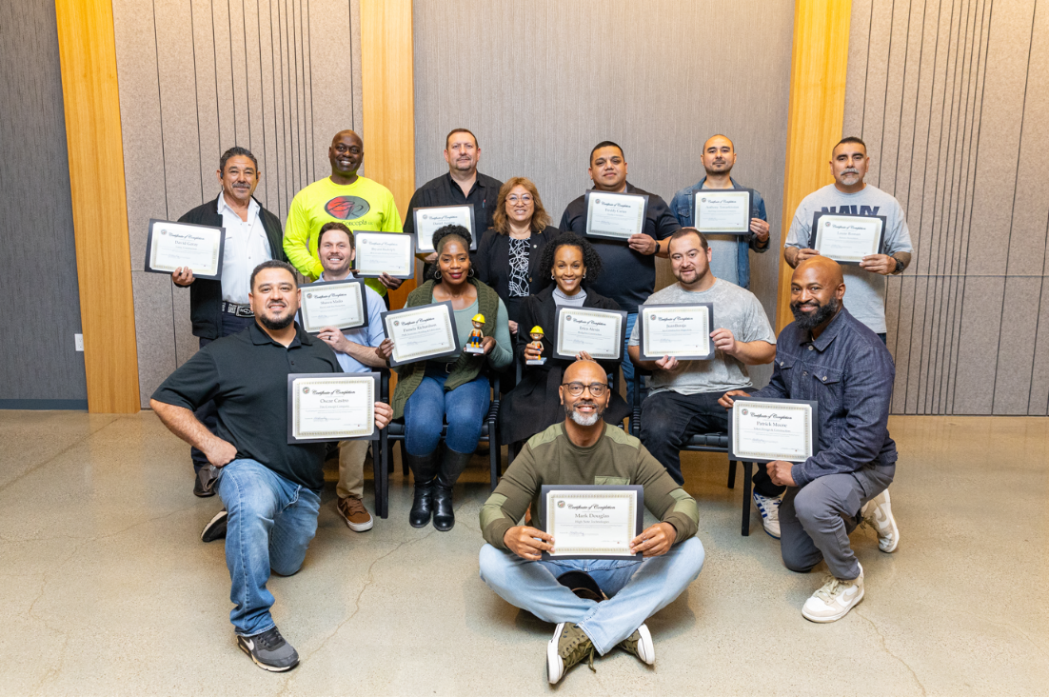

*Academy graduates display their certificates of completion with Lynda McGlinchey, standing in the center of the back row. Ms. McGlinchey serves as a Compliance Program Manager II, Office of Contract Compliance, City of Los Angeles.*

Lynda McGlinchey, Compliance Program Manager II, Office of Contract Compliance, City of Los Angeles, attended the graduation ceremony as a representative from the City of Los Angeles. While addressing the graduates of the academy, she stated, “The City of L.A. thinks it’s really important because this helps you prepare more than anything. What we want when you actually break in and work with us is that you’re successful. Historically, I’ve seen contractors get so excited because they were listed on one bid, then another bid, and another ... In our Small Sidewalk Program, we ended up getting 35 responses, 34 from contractors; of those 34, 22 are first-time bidders with us. Of the 34, 80% of them came from the CDABP. We want to continue to work with all of you and make sure you have those opportunities. That when those opportunities come, you’re successful. That’s why we support the program you just went through and everything else that Merriwether & Williams offers. We don’t want you just to get a bid; we want you to be successful and, from that, grow.”

The Construction Bidding & Estimating Training Academy has demonstrated its value to contractors seeking skill improvement, professional collaboration, and staying updated on industry trends through a blend of in-person and virtual training sessions, coupled with a practical, project-based approach.

A significant academy feature is the mock bid project, where participants worked together in teams to complete. Karla Talisse, Contractor Development Manager with MWIS, who reviewed the project with the participants, said, “As a Contractor Development Manager, I firmly believe that guiding contractors through the Bidding and Estimating Academy is a pivotal first step toward success. This program equips participants with essential skills and insights, laying a solid foundation for understanding the intricacies of pursuing opportunities with our agencies. By investing in this initial learning journey, we empower contractors to navigate the complexities of the bidding process confidently.”

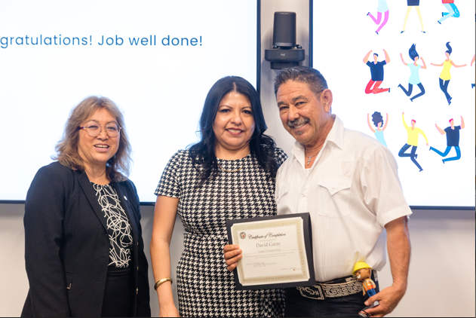

*Program participant David Garay, right, Owner & CEO of Garay Construction, receives his graduation certificate from Rosa Osorio, center, Assistant Program Manager, MWIS, and Lynda McGlinchey, left, Compliance Program Manager II, Office of Contract Compliance, City of Los Angeles.*

One graduate was David Garay, Owner & CEO of Garay Construction. Mr. Garay, while reflecting on his experience in the program, said, "I am immensely grateful for the exceptional guidance and transformative impact that Merriweather & Williams' bidding and estimating academy program has brought to our company. Their innovative approach and unwavering support have been instrumental in our growth and success. I wholeheartedly recommend their program for its unparalleled value in providing top-notch guidance and training events that have truly elevated our team's capabilities and performance. A heartfelt thank you to Karla Talisse, our dedicated Contract Development Manager, for her outstanding work in facilitating our partnership with Merriwether & Williams. Your expertise and dedication have been invaluable in ensuring the success of our collaboration. We are truly grateful for your unwavering support and commitment to excellence. Thank you for being an essential part of our team.”

The Construction Bidding and Estimating Training Academy generally received favorable participation and feedback from attending companies. Contractors gained substantial knowledge and cultivated new connections through networking with similar small and diverse construction firms. This networking led to the formation of potential partnerships. Participants acknowledge that the acquired knowledge from their investment of time and effort during the academy would facilitate business growth, enhance capacity, and optimize their ability to capitalize on public works opportunities.

For more information on the Los Angeles Regional Contractor Development and Bonding Program and future training sessions, visit our website at [LAConDev.com](https://www.lacondev.com/).