RADIO BILINGUE
03/30/23 (Thu.)

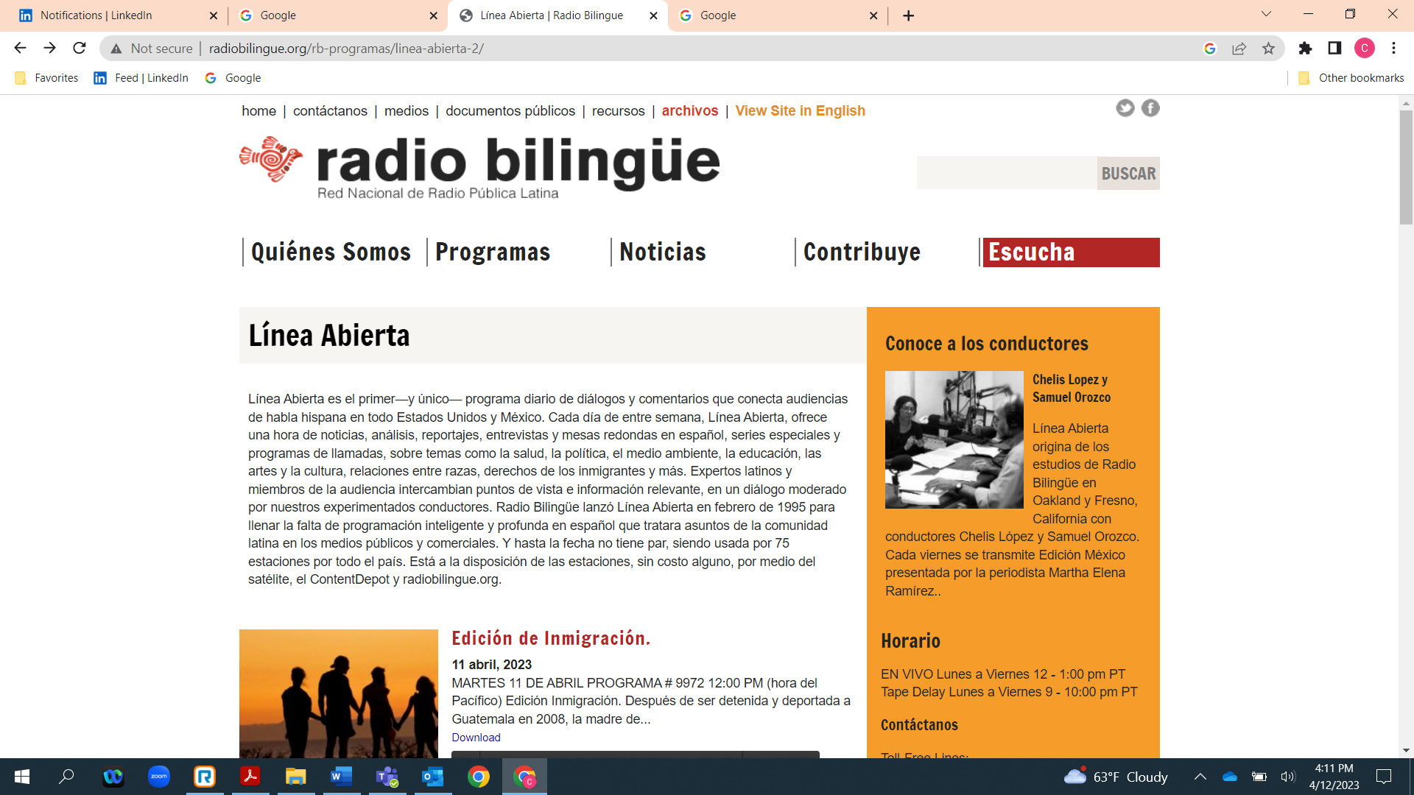

Radio Bilingue, a Spanish language radio station, interviewed Mario Cordero, the executive director of the Port of Long Beach (POLB), on its Linea Abierta interview show. The POLB is part of the Equity in Infrastructure Project (EIP), where Ingrid Merriwether, the CEO of Merriwether & Williams Insurance Services (MWIS), serves on the Advisory Council. MWIS pitched this interview to Radio Bilingue and arranged for Mr. Cordero to be interviewed. Mr. Cordero was interviewed 40 minutes into the 60-minute show, so he talked for the last 20 minutes or so. Below is a link to a recording of the show.

http://radiobilingue.org/wp-content/uploads/2023/03/la_230330_2.mp3

A Summary of the Interview in English

At the Port of Long Beach, there are lots of opportunities in construction related to President Biden’s infrastructure bill signed last year. But for minority and woman owned construction contractors, it is difficult for them to take advantage of these opportunities.

Mario Cordero was asked how he got started in the industry, and he mentioned that he was a licensed contractor in 2003 and was asked to participate on a task force under the Obama administration to see how minority owned construction companies can get more involved. Shortly thereafter, he was appointed to serve as a commissioner on the board of the Port of Long Beach.

Mr. Cordero mentioned that information, education, and training are all very important for minority owned contractors to learn how to get more involved with these opportunities. He said that at the Port of Long Beach, they have a process to enable these companies to obtain all of this. Mr. Cordero also mentioned that networking and the contacts one makes in the industry can help one get more access to opportunities. President Biden realized that the percentage of minority owned construction contractors was low, and this became very important to him. Mr. Cordero said that because of the infrastructure bill, there are millions of dollars out there, and companies need to get in on their “piece of the pie.”

Another important factor is to know the process of how to gain access to these opportunities. He mentioned the value of being involved in their communities, joining the local chamber of commerce, etc., to gain more knowledge about what opportunities are available. The radio host asked him what programs are available. Mr. Cordero said that outreach programs are available to get to know more about solicitations, opportunities, etc.

The above translated summary was done by Rick Casillas, Jr., of Merriwether & Williams Insurance Services.

