In Case You Missed It (ICYMI):
CONTRACTORS LEARN ABOUT strategic marketing IN WEBINAR

By engaging in effective marketing efforts, contractors can reach a wider target
audience, which can lead to more business opportunities.

That was one of the main points of Zahn Patin, founder of the Wonder Group, during a webinar entitled, “Strategic Marketing for Contractors,” held on February 27, in conjunction with Merriwether & Williams Insurance Services (MWIS). MWIS, a Hub International company, administers various contractor development and bonding programs for municipalities.

Topics covered included: marketing fundamentals, lead generation and development, marketing materials, bidding strategies, follow-up and relationship-building, budget-friendly marketing, and leveraging professional credentials.

“Are you bidding, or are you selling?” asked Patin. “This is a really important question to ask as a contractor, especially if you are working a lot in the government space -- you may be familiar with the bidding process, but maybe you haven’t actually started selling, which is what the essence of marketing is about.”

When you start selling, you start to think about the reasons why people should buy your services and what makes your company stand out from other companies. No one will know who you are without marketing, she added.

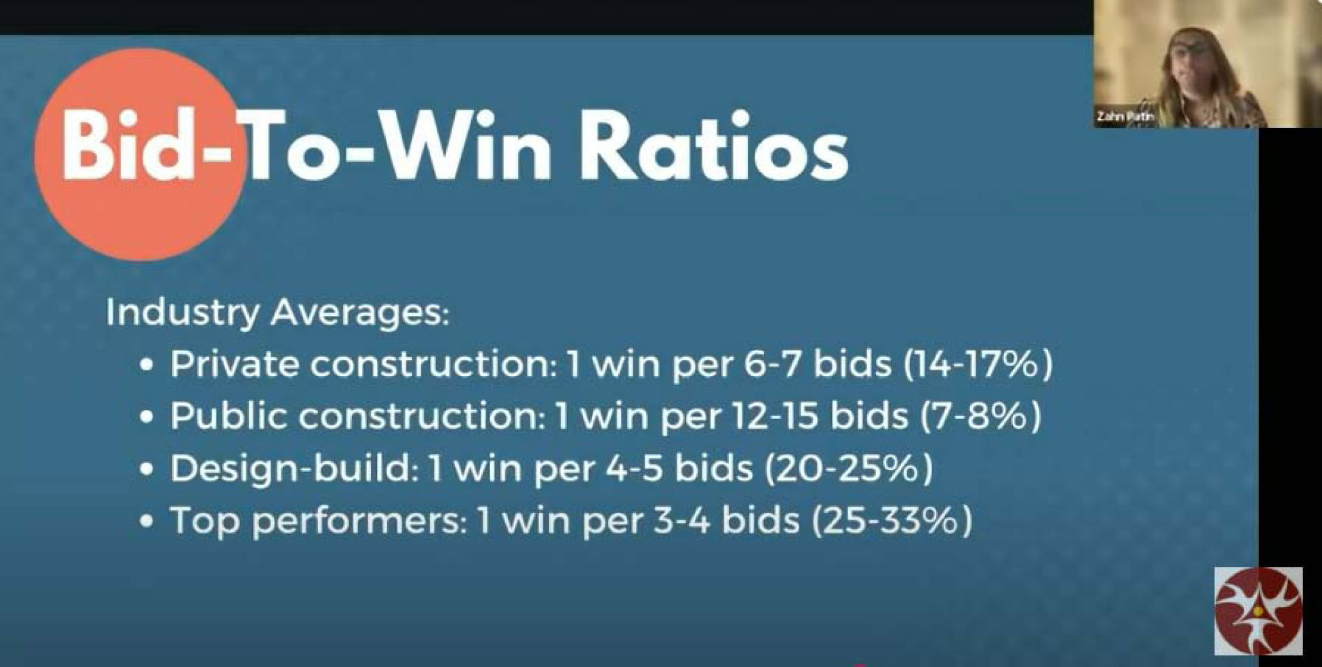

Bid-to-win ratios were among the topics Zahn Patin,
founder of the Wonder Group, talked about during the webinar.

Patin said that marketing matters for the following reasons:

- Construction is relationship-driven but highly competitive.
- Contractors with marketing plans average 23% higher annual growth.
- Marketing return on investment (ROI) in construction averages 5:1 when properly executed.
- It turns one-time projects into repeat business.

“If you are too busy to market your business, your business will start to shrink because you won’t be able to sustain it and build a pipeline for the future,” she said.

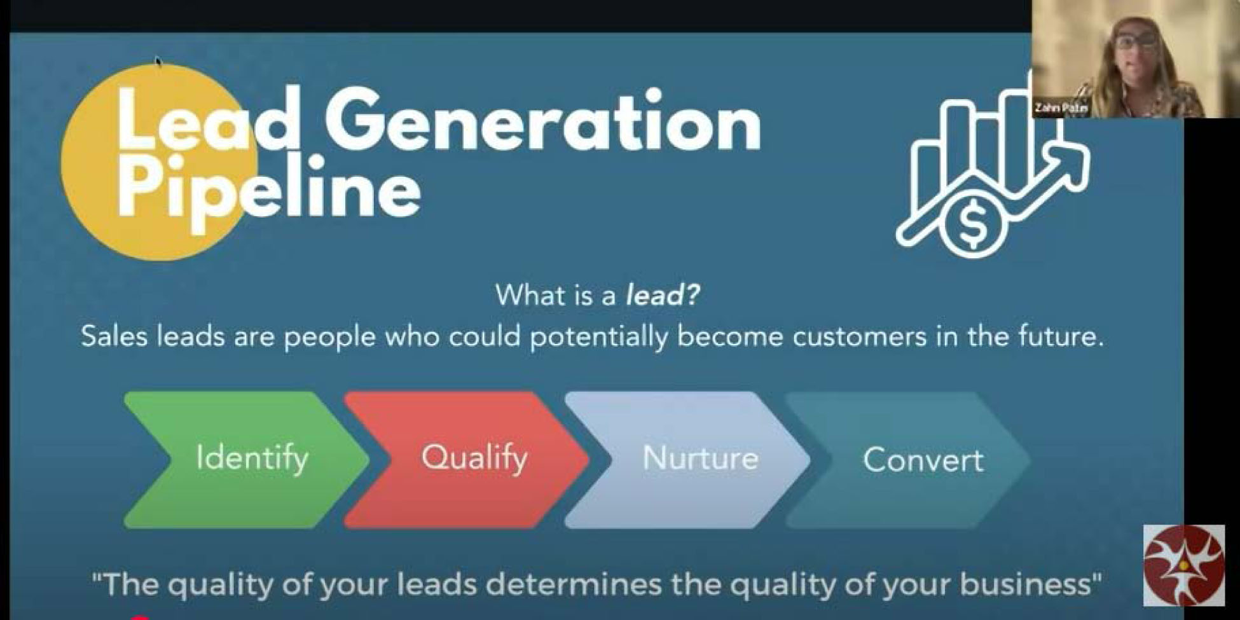

“Contractors need to identify, qualify, nurture and convert
leads to gain customers.”

-- Zahn Patin

One way to overcome some of the marketing challenges is through a lead generation pipeline. Sales leads are people who could potentially become customers in the future. “Contractors need to identify, qualify, nurture and convert leads to gain customers,” said Patin.

Engaging in outreach activities, such as attending conferences, is also a critical component of effective marketing, said Patin. She suggested generating leads from public bid boards, by establishing general contractor relationships, through referral networks, going back to past clients, attending industry events, building a digital presence, and by joining industry associations.

Another critical component of marketing for contractors is the creation of a capability statement, a one- or two-page document with key information about your business. Some of the essential elements of a capability statement include a company overview, core services and specializations, past project highlights with metrics, key personnel qualifications, certifications and credentials, and contact information. Contractors interested in creating a capability statement can contact MWIS for assistance.

Patin said that other basic marketing materials should include business cards that stand out, project portfolios (digital and print), jobsite signage, vehicle and equipment branding, email signature with credentials, and branded proposal templates.
The full webinar can be viewed by clicking here.

