MWIS CO-HOSTS WORKSHOP WITH LA CITY COUNCILMAN TIM MCOSKER
ON NAVIGATING CITY CONTRACTING OPPORTUNITIES

On November 14, Merriwether & Williams Insurance Services (MWIS) co-hosted a workshop entitled, “Navigating LA City Contracting Opportunities,” with City Councilman Tim McOsker. The webinar is a component of the LA Regional Contractor Development and Bonding Program (CDABP), which MWIS, a Hub International Company, administers for the City of Los Angeles, LA Metro, and the County of Los Angeles.

This workshop is part of an ongoing outreach initiative aimed at engaging small, local, and diverse contractors across Los Angeles by providing assistance and bonding support in public procurement. The mission of the CDABP is to increase the number of small and local contractors bidding for public contracts, thereby creating a more competitive and inclusive pool of bidders. Additionally, the program seeks to generate wealth and growth opportunities for these contractors.

Councilman McOsker, who represents District 15, opened the event by welcoming the contractors and offering a brief overview of the program and its mission. He emphasized the importance of seeking help and remaining persistent in achieving goals. The councilman highlighted how the CDABP can assist them in their efforts.

He said, “It is crucial to take advantage of the numerous benefits and resources that the CDABP offers. This program provides an excellent opportunity to stay informed about the latest public contract opportunities and to learn how to leverage them effectively. Keep in mind that, with persistence and the assistance of the CDABP, you can maximize your potential and achieve your goals. Don't let this opportunity pass you by!”

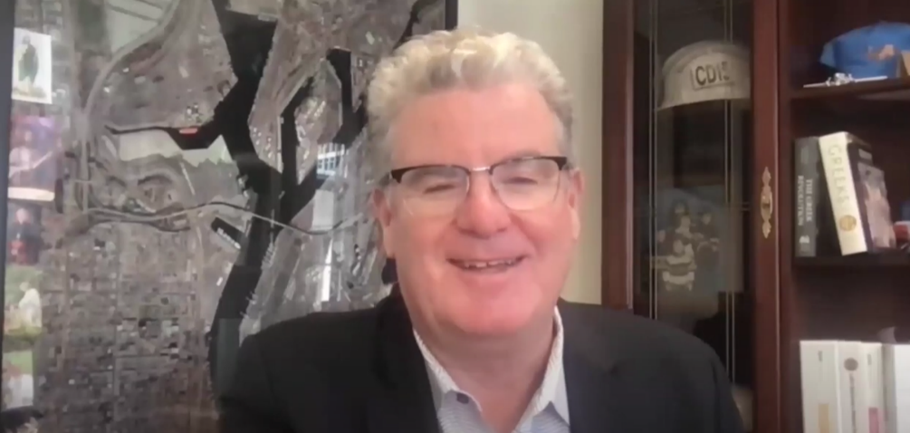

“Keep in mind that, with persistence and the assistance of
the CDABP, you can maximize your potential and achieve
your goals. Don't let this opportunity pass you by!”

-- LA City Councilman Tim McOsker

Representatives from the city’s proprietary departments spoke during the workshop about opportunities available to small and local contractors in their respective areas and about how contractors can get started. Speakers from the Port of LA (POLA), the LA Department of Water and Power (LADWP), Department of Public Works’ Bureau of Contract Administration (BCA), and LA World Airports (LAWA), as well as a representative from the CDABP, shared valuable insights into the procurement process, certifications, and the range of opportunities currently available for small and local contractors within their departments.

To view a recording of the entire webinar, click on this link.

The CDABP team at MWIS is available to assist contractors at every stage of the contracting process. For more information about the program, please visit the following website: https://www.lacondev.com.

