KEST-AM (1450) RADIO

03/22/23 (Wed.)

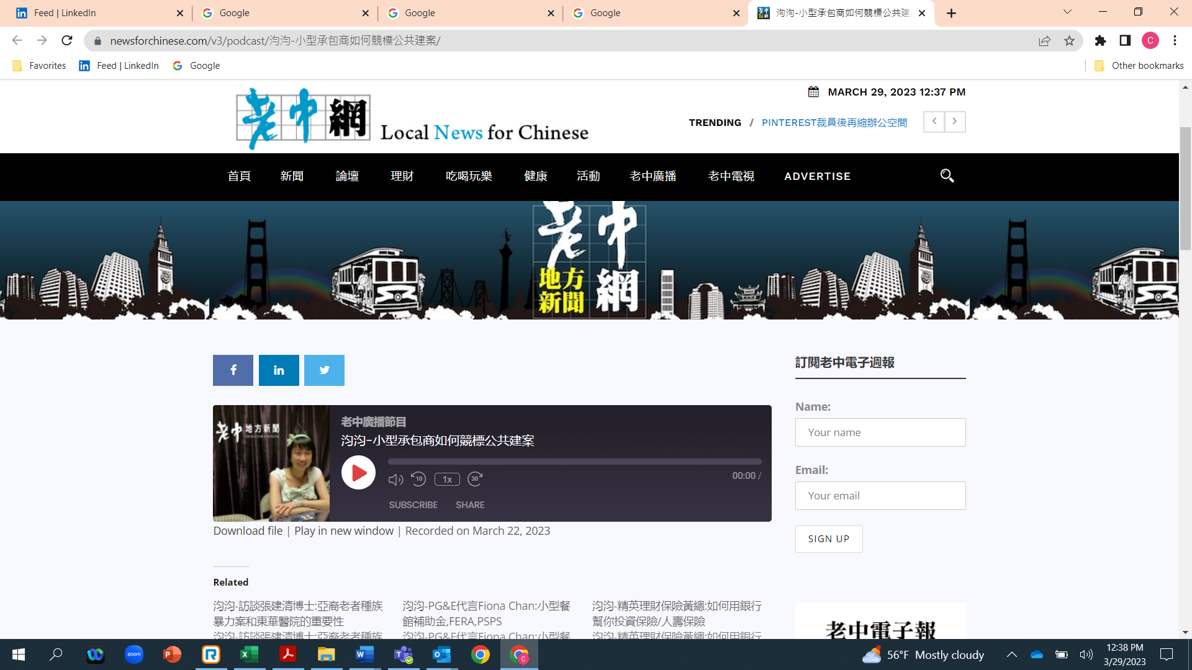

Ms. Jean Ho, a reporter with “News For Chinese,” a Chinese language radio outlet, interviewed, in Mandarin, Lina Tan, the CEO of Pilot Construction Management, Inc. The interview aired on KEST-AM (1450) radio on Wednesday, March 22, at roughly 1 p.m. PDT. KEST radio can be heard throughout the San Francisco Bay area.

The radio program started with about eight minutes of news, followed by some commercials, and then came the interview with Lina Tan. Here is a link to the interview:

<https://newsforchinese.com/v3/podcast/%E6%B1%AE%E6%B1%AE-%E5%B0%8F%E5%9E%8B%E6%89%BF%E5%8C%85%E5%95%86%E5%A6%82%E4%BD%95%E7%AB%B6%E6%A8%99%E5%85%AC%E5%85%B1%E5%BB%BA%E6%A1%88/>

No radio transcript is available in Mandarin. However, when Lina Tan was asked to provide a summary of the interview, she wrote the following: “During the interview, I shared the story about how Pilot Construction started its business in the City and County of San Francisco with Merriwether & Williams Insurance Services’ (MWIS) Contractor Development Program. I said that in 2009, MWIS helped Pilot Construction with its first project, $300,000 in size. In 2018, Pilot Construction graduated from MWIS's program. I communicated that Pilot Construction became successful because of MWIS's help. I believe that this is a successful interview, and I am hoping more small businesses will get help from MWIS.”