IN CASE YOU MISSED IT (ICYMI):

MWIS HOSTS WEBINAR ON CONTRACTOR TEAMING

AGREEMENTS AND JOINT VENTURES

Entering into a teaming agreement or joint venture with another contractor can often result in a profitable outcome. Pooling resources, expertise, and finances with other companies to achieve a common goal, while sharing the project’s risks and rewards, can result in a win/win situation.

Zahn Patin, Founder, and Jason Goree, Chief Strategy Officer, of the [Wonder Group](https://www.thewondergrp.com/), addressed the advantages of entering into a teaming agreement or joint venture with other contractors during a October 29 webinar hosted by Merriwether & Williams Insurance Services (MWIS), a Hub International Company. The webinar was a component of the Los Angeles Regional Contractor Development and Bonding Program (CDABP), which aims to assist small, local, and diverse construction contractors. MWIS administers the CDABP on behalf of the City of Los Angeles, LA Metro, and the County of Los Angeles.

“Understanding why you love to do this job, when you need to start a partnership, and what your impact is, serves as the foundation of your business and your business structure,” said Mr. Goree. “This will let you know when to make a deal and when to walk away.”

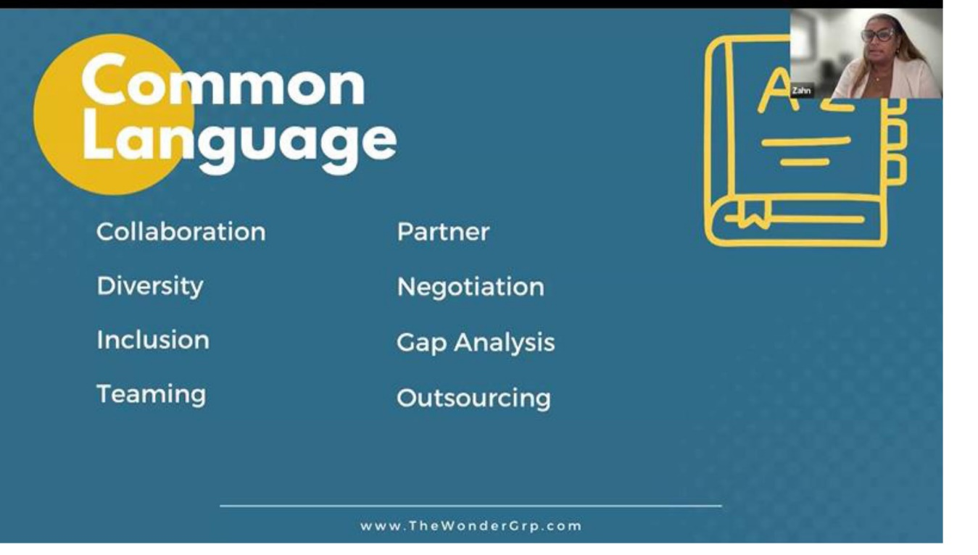

Zahn Patin, Founder of the Wonder Group, defined common

terms used in the forging of teaming agreements and joint ventures.

Ms. Patin raised the question of how contractors view other firms in their trade or service area: As a competitor or a collaborator. “It really depends on the situation,” she said. “We may actually go to a pre-bid meeting and realize that someone is more of a potential collaborator rather than a competitor because we go after the same work, but together we can scale and do more work. There may be an opportunity when there is a capacity limit.”

When you hear the word “collaboration” in the marketplace, to talk about ways we are coming together, and in the official definition, it’s working with someone to produce something, said Ms. Patin. The term “partner” is a person or entity involved in a business on a contractual basis and shares in the profit and loss and operation, said Mr. Goree.

“The profit and loss sharing element of partnerships is key because that means that everybody has skin in the game,” said Ms. Patin.

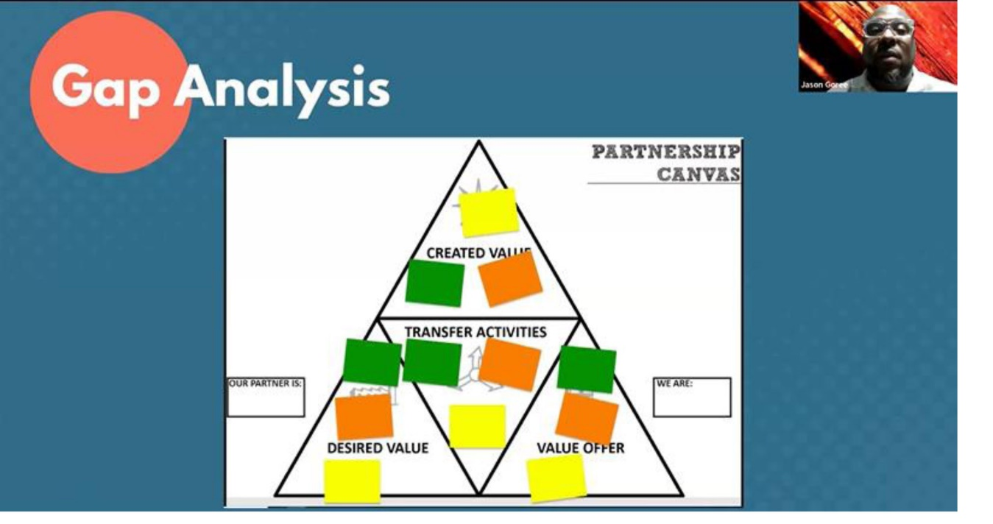

“Gap analysis is a method of assessing the performance

of your business to determine whether business

objectives are being met.”

-- Jason Goree, Chief Strategy Officer of the Wonder Group

Mr. Goree discussed the importance of conducting a gap analysis. “Gap analysis is a method of assessing the performance of your business to determine whether business objectives are being met,” he said. “Once I set up objectives and requirements to get there, and then I can measure it along the way, and as I measure it, I do an analysis of where the gaps are.”

Ms. Patin discussed the concept of “Build, Borrow, Bond,” which focuses on strengthening a contractor’s team and brand. The build aspect concerns investing in your team, and attracting, recruiting, training and retaining employees or contractors. The borrow element has to do with outsourcing to a third party that performs that service. Bond aspect deals with building relationships with teaming partners.

“When we talk about bonds, it doesn’t have to be permanent,” said Mr. Goree. “We’re talking about ‘I’m trying to get somewhere, and I need to connect with this person or entity, and in the pathway to getting there, I bring something to the table just as they do.’ It’s a mutual benefit.”

Ms. Patin and Mr. Goree also touched on the importance of expectations versus agreements. “When you start talking about expectations, I say that unexpressed expectations are nothing but premeditated frustrations,” said Mr. Goree. “Nobody in business or a relationship is obligated to your expectations. You are the only one that is bound by your expectations. The only thing that a person can be obligated to is what you agree to.”

To watch the entire video of the webinar, go [here](https://www.youtube.com/watch?v=mfQOxQrpNqc).

In addition to webinars like this one, the LA Regional Contractor Development and Bonding Program offers a variety of other services, available at no cost, to assist small, local, and diverse contractors in accessing public works contracts and in building their business capacities. For more information on the CDABP, go online to [www.LAConDev.com](http://www.LAConDev.com).