In Case You Missed It:
A Layman’s Guide to Contract Terms

Contractors are now faced with understanding complex and complicated construction contracts, and they need to be prepared to navigate a contract to ensure that they comprehend bidding requirements, scope of work, scheduling, claims, and disputes.
The importance of becoming familiar with contract terms was discussed in-depth by Jennifer Elmore, CDP Project Manager with Merriwether & Williams Insurance Services (MWIS), a HUB International Company, during a webinar entitled, “A Layman’s Guide to Contract Terms,” held on July 30. Topics covered included: guidelines for the bidding phase of contracting, interpreting actual contractual language, the impact of contract provisions on your business, and contractual compliance to preserve contractor claims.

“The purpose of a contract review is to ensure you are comfortable and that you understand the legal agreements and terms and that legal and financial risk is reduced as far as possible to protect the interests of your business,” said Elmore. “The contract is perhaps the most important part of a construction project, and getting it right is the pathway to a successful project. Given the complexity of construction contracts and the risk involved, it is important to protect your interests should something unexpected occur.”

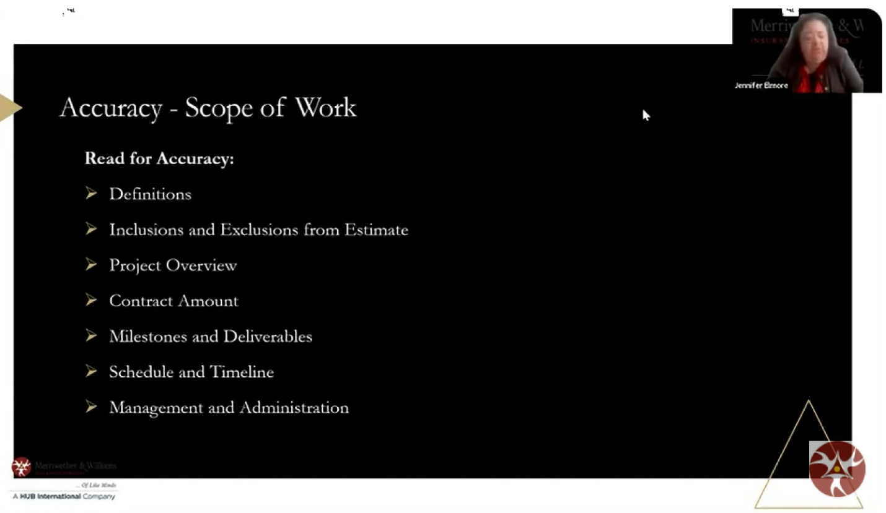

“Your bid and any negotiation should be in the contract.”
-- Jennifer Elmore

When reading the contract for accuracy, particularly the scope of work, contractors should pay particular attention to definitions, inclusions and exclusions from the estimate, project overview, contract amount, milestones and deliverables, schedule and timeline, and management and administration, said Elmore.

“Once a contract is signed, any discussion about the scope or project, if it is not part of the contract, is no longer valid. You want to always make sure to read the scope of work for accuracy to make sure everything that you agreed upon is in the contract. Look for clear wording and terminology,” she added.

Dispute resolution may also be an important part of the contract process, said Elmore. Many contracts stipulate that the parties will go to arbitration if there is a dispute; many contracts stipulate that there are other options such as mediation or lawsuits. Contractors will also want to note who is responsible for attorney’s fees.

She also pointed out that liquidated damages (LDs) are penalties for completing a project after its scheduled completion date. LDs are assessed to compensate the project’s owner for lost revenues due to delays on the project and may be passed on to the subcontractor. LDs are damages that are meant as a fair representation of losses in situations where actual damages are difficult to ascertain.

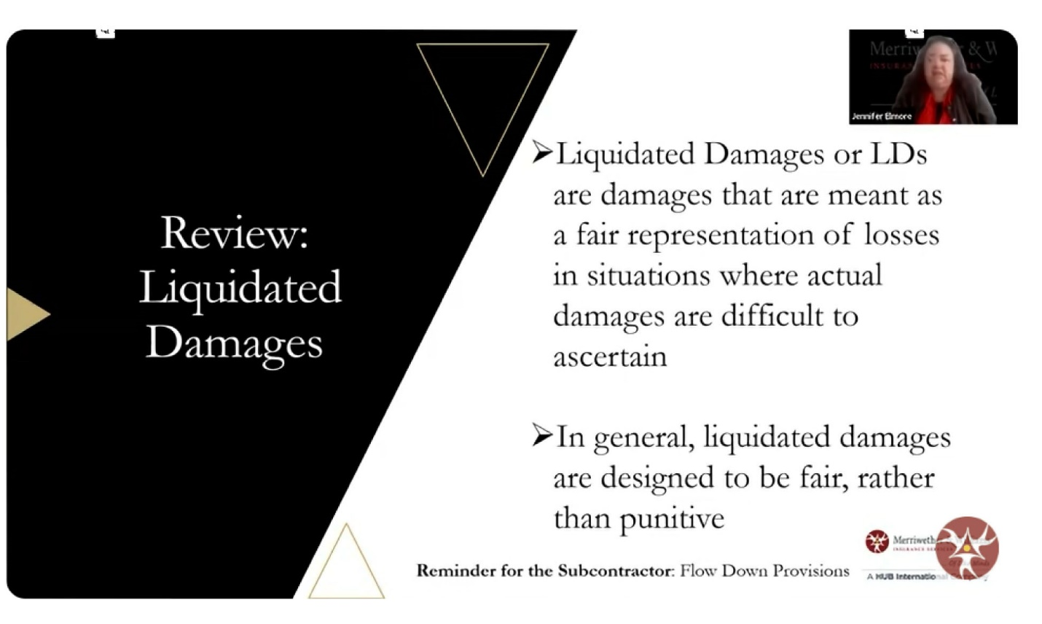
“Liquidated damages should be proportional to the contract amount.”
-- Jennifer Elmore
Contractors should also be aware of “flow down” language, she said. A flow down clause is a contract provision by which the parties incorporate the terms of the general contract between the owner and the general contractor into the Subcontract Agreement.

“If you find a flow down clause in your contract, make sure you request a copy of the prime contract and all the documents so you can review them. The primes have to share them with you if you request them,” she advised.

Elmore offered these main tips for contract review: understand the contract to discuss strategies with your business partners; hire a lawyer to review your contracts; understand boilerplate language, use Adobe to search for terms; and initiate an AI legal review.

A “Contract Review Checklist” can be accessed by clicking here.

Contract review resources offered to contractors by MWIS include assessment and targeted technical assistance, field support services, and surety and funding support.
The full webinar can be viewed by clicking here.

