MWIS CO-HOSTS WORKSHOP WITH LA COUNTY SUPERVISOR AND METRO BOARD CHAIR JANICE HAHN ON CONTRACTING OPPORTUNITIES

On March 26, Los Angeles County Supervisor and LA Metro Board Chair Janice Hahn co-hosted a virtual workshop entitled, "Navigating LA County and Metro Contracting Opportunities,” which focused on the importance of mitigating barriers for small and local contractors working in the public contracting sector. The workshop was a component of the LA Regional Contractor Development and Bonding Program (CDABP). Merriwether & Williams Insurance Services (MWIS), a Hub International company, administers the CDABP on behalf of LA County, LA Metro, and the City of LA.

Supervisor Hahn, who represents District 4, graciously extended a welcome to all attendees, instilling hope among those aspiring to do business with the County. She remarked, “For too long, contracting opportunities have been out of reach for many businesses that don’t have the resources to devote to getting through what can be a very complicated process. For years, I have been a champion of breaking down these barriers and giving more local, small, and diverse businesses the support they need to compete with bigger companies and win these contracts.”

Supervisor Hahn is a steadfast proponent of the CDABP, which offers essential resources to small, local, and diverse contractors in Los Angeles County, empowering them to develop and equip their businesses for public contracting opportunities. One of the goals of the CDABP is to assist in building generational wealth within diverse communities and to help strengthen the economic fabric of communities.

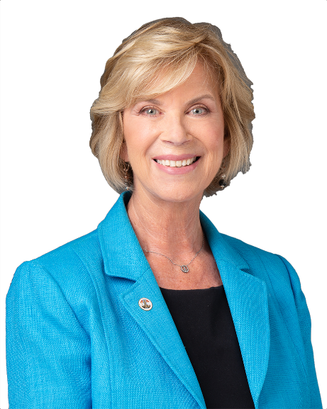

“For years, I have been a champion of breaking down these barriers and
giving more local small and diverse businesses the support they need to
compete with bigger companies and win these contracts.”

LA County Supervisor Janice Hahn, District 4

Officials from Los Angeles County departments and Metro were invited to discuss upcoming contracting opportunities for prime and subcontractors and additional resources, certifications, and support available. Representatives from the County Department of Economic Opportunity (DEO), Metro’s Diversity & Economic Opportunity Department (DEOD), and LA County Department of Public Works (DPW) explained the essentials of engaging with their departments. They also urged attendees to participate in public contracting and to take advantage of the extensive support and guidance offered to small, local, and diverse businesses.

A video recording of the workshop can be found by clicking here.

The Regional CDABP is dedicated to fostering the growth and development of small, local, and diverse contractors in Los Angeles County. For those interested in joining the program, please go online to www.LAConDev.com for more details, or reach out via email at mwisinfo@imwis.com.

