IN CASE YOU MISSED IT (ICYMI)

LA COUNTY SUPERVISOR AND METRO BOARD MEMBER LINDSEY HORVATH HOSTS A WORKSHOP WITH MWIS ON
INFRASTRUCTURE CONSTRUCTION OPPORTUNITIES

On February 22, Los Angeles County Supervisor and Metro Board Member Lindsey Horvath co-hosted a virtual workshop with Merriwether and Williams Insurance Services (MWIS) entitled, “Navigating LA County and Metro Contracting Opportunities.” The workshop is a component of the Los Angeles Regional Contactor Development and Bonding Program (CDABP), which MWIS administers on behalf of the County of Los Angeles, LA Metro, and the City of Los Angeles.

Austin Cyr, Deputy Director of Community Affairs for Supervisor Horvath, welcomed attendees. Mr. Cyr said that Supervisor Horvath, who once owned her own small business, is committed to the success of small businesses and diverse contractors. "The Supervisor is driven to support small and diverse contractors on their journey toward success. She truly believes that all businesses, regardless of size, deserve equal opportunities,” said Mr. Cyr.



"The Supervisor is driven to support small and diverse contractors on their journey toward success. She truly believes that all businesses, regardless of size, deserve equal opportunities,”

Austin Cyr, Deputy Director of Community Affairs,
Office of LA County Supervisor Lindsey Horvath

The webinar speakers provided a wealth of information and insight into critical parts of the public contracting and certification process during the event. Attendees were highly engaged and submitted their questions throughout the webinar, participated in polls, and engaged in a Q&A section after the presentations.

The virtual outreach workshop included a clip from a KTTV-TV Channel 11 broadcast featuring two CDABP contractors who were successful in bidding for public contracts. The participants noted that the help CDABP offered facilitated the procurement process. Hal Eisner, the host, asked, “How effective has [the CDABP] been for you?” Juan Garcia, CEO of PG Cutting, responded by saying, “Very effective … You feel this sense of support when you’re bidding on something. In fact, right now, I’m bidding on a big project in a week or two with LA Metro, and I need more bonding for this project, so we already have the wheels in motion. Without that, I would be a little lost.”

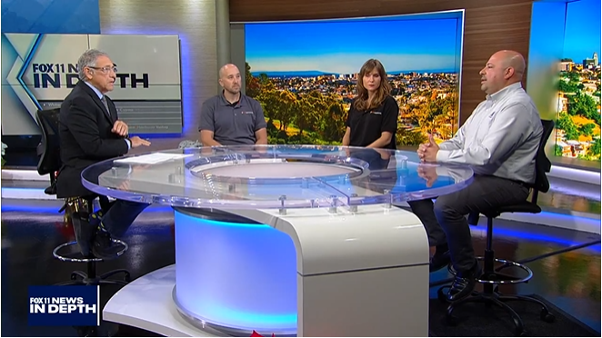

“You feel this sense of support when you’re bidding.”

Juan Garcia, CEO, PG Cutting Services.

The CDABP is a contractor support initiative that promotes the growth of small, local, and diverse businesses. The office of Supervisor Horvath and MWIS invite small, local, and diverse contractors to take advantage of the CDABP services, which are offered at no cost. For more information on the program, visit www.LAConDev.com.

