In Case You Missed It (ICYMI):
MWIS Hosts webinar on Financial fundamentals
for construction contractors

On September 25, Merriwether & Williams Insurance Services (MWIS) hosted a webinar entitled, “Financial 101 for Construction Contractors,” which unlocked the secrets to financial success in the construction industry. The webinar was offered as part of the Los Angeles Regional Contractor Development and Bonding Program (CDABP), which MWIS, a Hub International Company, administers on behalf of the City of Los Angeles, LA Metro, and the County of Los Angeles.

The webinar was tailored specifically for contractors and construction business owners, and this hands-on event demystified the financial fundamentals essential for managing and growing their businesses.

The event presenter was John Miller, Contract-Based Finance Program Manager with MWIS. Mr. Miller taught attendees how to understand key financial statements, budget and forecast effectively, manage project costs and profit margins, and improve financial decision-making.

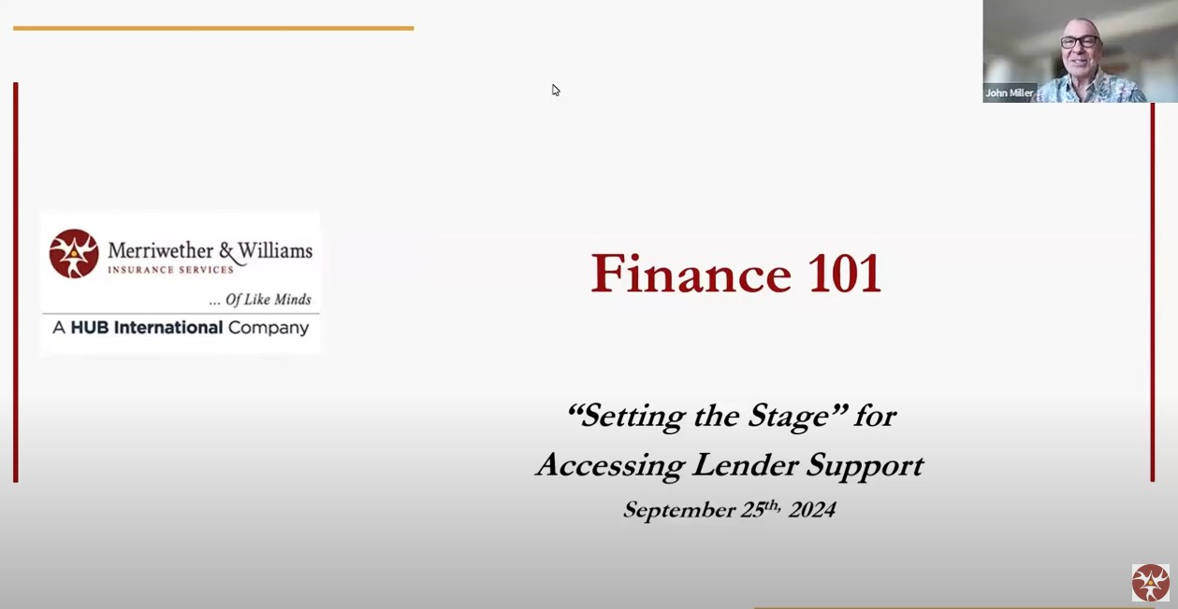

“A SWOT analysis will help you identify opportunities and risk
and assist you in making smarter funding choices.”

-- John Miller, Contract-Based Finance Program Manager MWIS

Mr. Miller emphasized underwriting loans for funding partners. He stressed the importance of constantly learning about finances to help push their companies forward. He covered personal, business and public finance fundamentals to help contractors distinguish the many types of finances.

Mr. Miller also stressed the importance of strategic planning and cash flow projections, which is a financial forecast that estimates the future inflows and outflows of cash for projects they are currently working on. Contractors were encouraged to conduct a strengths, weaknesses, opportunities, and threats (SWOT) analysis. Mr. Miller said, “A SWOT analysis will help you identify opportunities and risk and assist you in making smarter funding choices.”

Throughout the webinar, Mr. Miller taught contractors how mastering cash flow projections can help maintain liquidity and can help meet their financial obligations. He also showed them how to be familiar with common debt structures to allow businesses to navigate funding options better and negotiate terms. Contractors also learned how to utilize a business model canvas to provide a visual framework for developing and refining business strategies, leading to sustainable growth.

To view the full webinar, click here.
Small, local, and diverse construction contractors are encouraged to participate in the LA Regional Contractor Development and Bonding Program, which is offered at no cost to them. For more information on CDABP, visit the following website: www.LAConDev.com.

