IN CASE YOU MISSED IT (ICYMI):
LA CITY COUNCILMEMBER BOB BLUMENFIELD HOSTS A WORKSHOP
WITH MWIS ON INFRASTRUCTURE CONSTRUCTION OPPORTUNITIES

On March 28, 2024, Los Angeles City Councilman Bob Blumenfield co-hosted a virtual workshop entitled, "Navigating LA City Contracting Opportunities," with Merriwether & Williams Insurance Services (MWIS). During this workshop, contractors learned about the LA Regional Contract Development and Bonding Program (CDABP), which MWIS administers on behalf of the City of Los Angeles, LA Metro, and the County of Los Angeles.
Councilmember Blumenfield, a strong supporter of the program, welcomed attendees to the webinar, which aims to educate small, local, and diverse contractors about the resources available through the CDABP and to share the success stories of contractors who have benefited from the program.
During the workshop, Councilmember Blumenfeld, who represents District 3, encouraged attendees to maximize their potential and become city contractors. This, he said, would not only benefit them personally, but also play a critical role in the city's continued recovery from COVID-19. “My hope at the end of this: you’re going be able to maximize your potential, become a city contractor … for your own benefit, but we’re also counting on you to play a critical role in this city’s continued recovery from COVID,” said the councilmember.

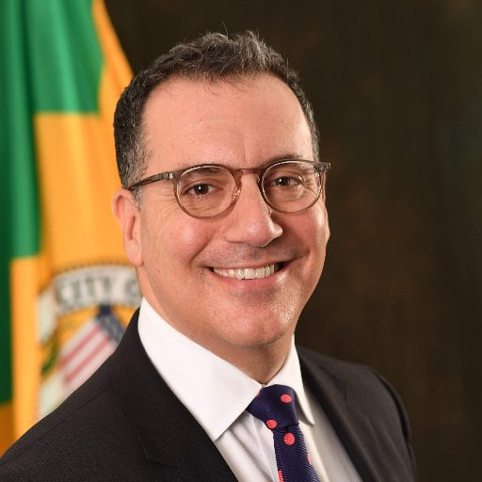

“My hope at the end of this: you’re going be able to maximize your potential, become a city contractor … for your own benefit, but we’re also counting on you to play a critical role in this city’s continued recovery from COVID.”
LA City Councilmember Bob Blumenfield, District 3

Attendees were shown a brief media clip from past KTTV-TV Channel 11 interview featuring host Hal Eisner and two contractors who had participated in the CDABP program. Their stories offered valuable insights, serving as examples of the success that can be reached with the support and guidance of the CDABP.
During the webinar, representatives from Los Angeles World Airports (LAWA), the Los Angeles Department of Water and Power (LADWP), the Bureau of Contract Administration (BCA), and the Port of Los Angeles (POLA) presented upcoming construction opportunities at the event.

Contractors were encouraged to utilize the CDABP services, which are offered at no cost to participants. More information on the program can be found on the CDABP website: www.LAConDev.com.

