In Case You Missed It (ICYMI):

MWIS HOSTS “understanding insurance for

contractors” WEBINAR

Insurance is a critical component of a contractor’s business strategy, offering protection, compliance, and credibility.

The importance of securing insurance for contractors was discussed in-depth by John Miller, Contract-Based Finance Program Manager with Merriwether & Williams Insurance Services (MWIS), a HUB International Company, during a webinar entitled, “Understanding Insurance for Contractors,” held on August 27. Topics covered included: different types of insurance, worker’s compensation, contractors’ equipment floater, professional liability or errors & omissions, owner-controlled insurance programs (OCIPs) and contractor’s controlled insurance programs (CCIPs) or wrap ups, and how to mitigate the impact of insurance cost to improve bidding.

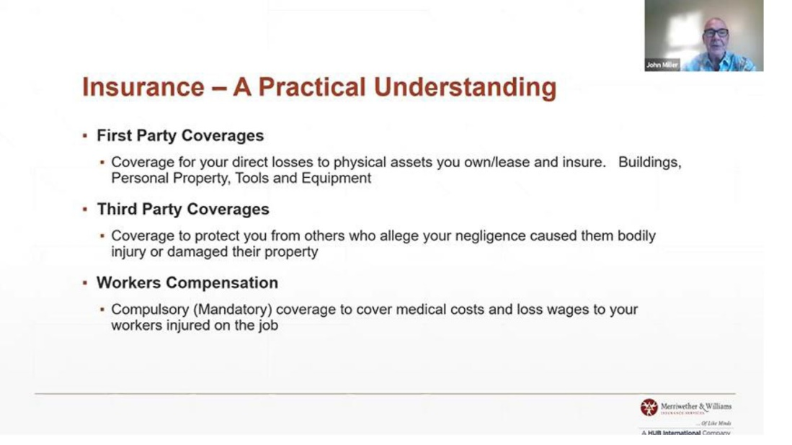

John Miller, Contract-Based Finance Program Manager with MWIS, outlined

the three fundamental types of insurance in the construction industry.

“From a practical coverage standpoint, the three coverages you will typically see are first party coverages, third party coverages and worker’s compensation,” said Miller. “In first party coverages, you are buying insurance to protect your assets like tools and equipment. The second type of coverage is third-party coverages for bodily injury and property damage. Worker’s compensation is required in whatever strategic market you happen to be in to cover medical costs for workers who are injured on the job. It is compulsory,” he added.

There are several types of insurance policies that the contractor will be dealing with through their broker. These insurance categories include: commercial general liability, worker’s compensation, automobile liability, contractor’s equipment floater, professional liability (also known as errors and omissions), builder’s risk, OCIP, and CCIP.

“In the realm of standard insurance requirements, your commercial general liability, you will have limits that are stipulated by a project owner in a prime position or by a general contractor (GC) if you are working in a subcontracted position,” said Miller. “Limits as stipulated by the owner or GC are typically $1 million, or $2 million limits in the aggregate. Now you can buy higher limits, but the economics of buying higher limits are up to you and what your insurance professional deem to be your exposures.”

Miller said that coverages under commercial general liability include bodily injury, third-party property damage, products/completed operations, personal/advertising injury, and medical payments.

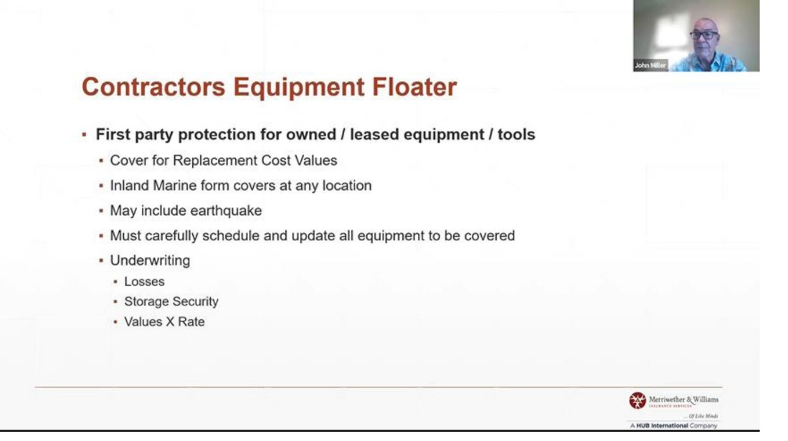

“The contractor’s equipment floater is essentially first-party protection for the equipment and tools that you own or lease,” explained John Miller.

“The contractor’s equipment floater is essentially first-party protection for the equipment and tools that you own or lease,” explained Miller. “It covers that equipment at your normal domicile, shop, storage yard, and in the field. It ‘floats’ with the equipment on whatever site it’s on. These policies are typically written on a replacement cost basis as opposed to an actual cash value.”

The professional liability or errors and omissions might be driven by a contract you sign, said Miller. It is needed for any form of construction management/consulting, and limits are dictated by the owner or prime consultant at no less than $1 million per occurrence. This professional liability is there to pay for your errors and omissions on your behalf should you make an error or omission in the design and/or engineering, he added.

Builders risk insurance, Miller explained, is coverage for property damage to a structure under the course of construction including loss or damage to materials intended to be part of the building. The builders risk is sometimes covered by the owner/GC under a project blanket limit, and contractors can purchase a blanket policy to apply to all work throughout the policy period. It is also project-specific coverage, he said.

“Read the contract to confirm who is responsible for procuring and who is responsible for the deductible,” advised Miller. “Take a close look at the contract and see what specific coverages are required, and make sure you are part of the ‘Named Insured’ if others purchase coverage.”

As far as OCIPs and CCIPs (also called wrap ups) are concerned, coverages which may be provided include general liability, builders risk, and worker’s compensation. The coverage applies only to on-site work.

“With OCIP’s and CCIP’s, you will be informed of coverage limits and terms, and you may want to compare that to your standard coverage,” said Miller. “You may also be required to submit insurance rating information to validate your insurance credit. It should also be noted that owner-provided coverages should be excluded from all change orders.”

The full webinar can be viewed by clicking **[here](https://www.youtube.com/watch?v=WqUH-CTNfYg)**.